Linear Acceleration
Please remember to photocopy 4 pages onto one sheet by going A3→A4 and using back to back on the photocopier

This booklet contains every higher level (and most ordinary level) questions that have appeared on exam papers from 1971 – 2023
Note that this topic was usually Question 1 on the old syllabus (up to 2022)
Fully worked solutions from the legend that is Dominick Donnelly here appliedmathematics.ie/index.php/students/exam-solutions
Solutions to HL 2023 and Sample Paper (plus lots more) from Joe Kennedy here: https://www.jkmaths.net/exam-paper-solutions
Screencasts of worked solutions to HL 2023 and Sample Paper (plus lots more) from Shane Molloy here: https://www.molloymaths.com/applied-maths

Exam Papers (in pdf and Word format) plus Marking Schemes (and lots more) from: thephysicsteacher.ie/exammaterialappliedmaths.html
A good idea is to look at as many sources as you can for solutions as there is often more than one approach and some can be much easier to understand and/or remember than others.
Screencasts of worked solutions to various older past paper question plus comprehensive resources for all topics

Questions from 2023 and Sample Paper (Ordinary level and Higher level) are left until the very end – page 48

You can find this document plus all other Applied Maths booklets on the homepage of thephysicsteacher.ie

Last updated: 04/12/2024
Noel Cunningham
Contents
Introduction 3
Ordinary level 5
Ordinary level Worked Solution 5
Velocity – time graphs 6
Velocity-time graph: Car starts from rest: Ordinary level Worked Solution 7
Using the tan of the angle to calculate the acceleration 7
Velocity-time graph: Car does not start from rest: Ordinary level Worked Solution 8
Exam Questions Ordinary Level 9
Trickier ordinary level questions 11
Two-car problems 12
Useful points of information 12
Two cars: Ordinary level Worked Solution 12
Ordinary level Two-Car problems 13
Higher level Two-Car problems 16
Useful points of information 16
Vertical motion (all Higher Level) 24
Introduction 24
Why do we take g as negative (-9.8) for the entire motion of the particle (up and down)? 25
How can the equation get away with not taking the distance travelled into account? 25
Vertical motion short exam questions taken from Physics papers 26
Vertical motion Applied Maths worked solution 27
Why are s and g negative? 27
Vertical motion Applied Maths exam questions 28
And one more time for the students at the back - When do we use a minus sign? 28
Classic exam question – camera dropped from a hot-air balloon 28
Common initial velocity 29
Slight Variations 31
Collisions 32
Velocity-time graphs 35
Acceleration followed immediately by deceleration (“rest to rest”) 35
Introduction 35
Acceleration followed immediately by deceleration exam questions 36
General velocity-time exam questions 37
Questions requiring F_{net} = ma 41
Fnet = ma (on a slope) 42
Answering Higher Level Exam Questions 1995 - 2009 44
Answers to Ordinary Level Exam Questions 2000 - 2017 48
Linear acceleration questions from 2023 and Sample Paper: Ordinary level and Higher level 51

Introduction

Time | Velocity
1 second | 10 m/s
2 seconds | 20 m/s
3 seconds | 30 m/s
4 seconds | 40 m/s
Consider an object which is falling through the air.
Its instantaneous velocity after one, two, three and four seconds is given in the table.

We can see that with every second that passes the velocity increases by 10 m/s.
Alternative ways of expressing this:
The velocity increases by 10 m/s per second or 10 m/s/s or 10 m/s² or 10 m s⁻².
Or we could just say that the acceleration is 10 m s⁻² (“ten metres per second squared”).

The unit of acceleration is therefore the metre per second squared (m s⁻² or m/s²).

It would be a bit of a coincidence if the acceleration was exactly 10 m s⁻². In reality if a ball is falling through the air its acceleration will be approximately 9.8 m s⁻² (assuming no air-resistance).
Acceleration is the rate of change of velocity with respect to time

$$acceleration= \frac{change in velocity}{time taken}$$

Equations of motion

When an object (with initial velocity u) moves in a straight line with constant acceleration a, its displacement s from its starting point, and its final velocity v, change with time t.
Note that both v and u are instantaneous velocities.

The following equations tell us how these quantities are related:

v = final velocity
v = u + at

s = ut + ½ at²

v² = u² + 2as

u = initial velocity
a = acceleration
s= displacement
t = time

The following is also sometimes useful: $s=\frac{(U+V)}{2}t$

Procedure for solving problems using equations of motion.
- Write down v, u, a, s and t underneath each other on the left hand side of the page, filling in the quantities you know, and put a question mark beside the quantity you are looking for.
- Write down the three equations of motion every time.
- Decide which of the three equations has only one unknown in it.
- Substitute in the known values in to this equation and solve to find the unknown.

Exam questions from physics papers – worked solutions

2005 Question 5 [Ordinary level]
A car accelerates from 10 m s⁻¹ to 30 m s⁻¹ in 5 seconds. What is its acceleration?
u = 10 m s⁻¹  v = 30 m s⁻¹  a = ?  s =  t = 5 s | v = u + at ⇒ a = ( v – u ) ÷ t  ⇒ a = (30 – 10) ÷ 5  ⇒ a = 4 m s⁻².
2021 Question 5 [Ordinary level]
A motorcar starts from rest and has an acceleration of 6 m s^{–2}.
Calculate the distance it travels in 12 s.
u = 0  v =  a = 6 m s⁻²  s =  t = 12 s | $$s=ut+\frac{1}{2}at^{2}$$  $s=0+\frac{1}{2}\left(6\right)({12}^{2})$  s = 432 m
2003 Question 5 [Ordinary level]
What is the shortest stopping time for a car which is travelling at 16 m s⁻¹ and has a maximum deceleration of 2.5 m s⁻²?
u = 16 m s⁻¹  v = 0  a = - 2.5 m s⁻²  s =  t = ? | v = u + at. 0 = 16 – 2.5t  t = 6.4 secs
2018 Question 12 (a) [Ordinary Level]
A train left a station from rest and accelerated at 0.4 m s⁻² to reach its top speed of 55 m s⁻¹.
Calculate how long it took the train to reach its top speed.
u = 0  v = 55 m s⁻¹  a = 0.4 m s⁻²  s =  t = ? | u = 0  v = 55 m s⁻¹  a = 0.4 m s⁻²  s =  t = ?

Ordinary level

Ordinary level Worked Solution
2008 OL
Four points a, b, c and d lie on a straight level road.
A car, travelling with uniform retardation, passes point a with a speed of 30 m/s and passes point b with a speed of 20 m/s.
The distance from a to b is 100 m. The car comes to rest at d.
Find
- the uniform retardation of the car
- the time taken to travel from a to b
- the distance from b to d
- the speed of the car at c, where c is the midpoint of [bd].

Solution
- v² = u² + 2as
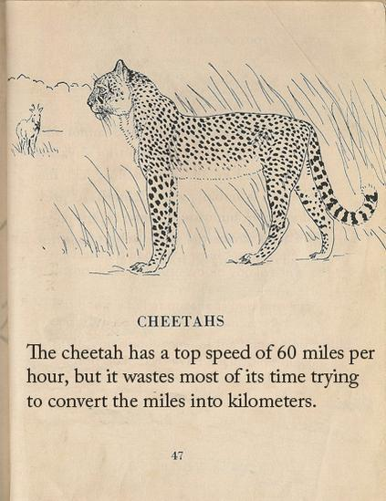
20² = 30² + 2(a)(100)
-500 = 200 a
a = - 2.5 m s⁻²

- v = u + at
20 = 30 – 2.5 t
t = 4 s

- v² = u² + 2as
0² = 20² + 2(-2.5)(s)
s = 80 m

- v² = u² + 2as
= 20² + 2(-2.5)(40)
= 200
v = 10√ or 14.1 m s⁻¹

Use equations of motion to prove 1 = 2
Take two of our standard formulae: v = u + at and s = ut + ½ at².
Assume a particle begins from rest so both formulae reduce to v = at and s = ½ at².
Cross-multiply to get a on its own on both sides: a = v/t and a = 2s/t².
Equate both right hand sides: v/t = 2s/t².
Divide both sides by t: v = 2s/t.
Substitute v for s/t on the right hand side (because velocity equals distance divided by time) and you get v = 2v, or 1 = 2 !!
Hint: The mistake here is to do with the concept of instantaneous velocity.

Velocity – time graphs

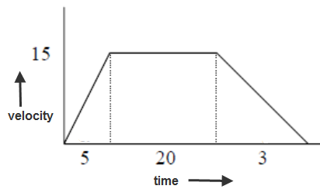
The area under a velocity-time graph corresponds to the distance travelled.
(it’s often quicker to use this than to use the equation s = ut + ½ at²)

In this example we can break the area under the graph into three separate sections.
The area of the first section is a triangle so the area = (½)(5)(15) = 37.5 m
The area of the second section is a rectangle so the area = (20)(15) = 300 m
The area of the third section is a triangle so the area = (½)(3)(15) = 22.5 m
Total area = 360 m

- These questions assume that the car is travelling at constant acceleration during each section – in a later chapter (Differential equations) we will see how to deal with questions where the acceleration is constantly changing.
- You should draw a velocity-time graph for every question, whether you are asked to or not, as it helps to visualise what’s happening.

- The slope of the line for a given stage corresponds to the acceleration of the object during that stage (this is something which isn’t important for Ordinary Level, but which will use it when answering Higher Level questions in sixth year).

- $Average speed= \frac{total distance}{total time}$

Velocity-time graph: Car starts from rest: Ordinary level Worked Solution
2007 OL
A car travels from p to q along a straight level road.
It starts from rest at p and accelerates uniformly for 5 seconds to a speed of 15 m/s.
It then moves at a constant speed of 15 m/s for 20 seconds.
Finally the car decelerates uniformly from 15 m/s to rest at q in 3 seconds.
- Draw a speed-time graph of the motion of the car from p to q.
- Find the uniform acceleration of the car.
- Find the uniform deceleration of the car.
- Find |pq|, the distance from p to q.
- Find the speed of the car when it is 13.5 metres from p.
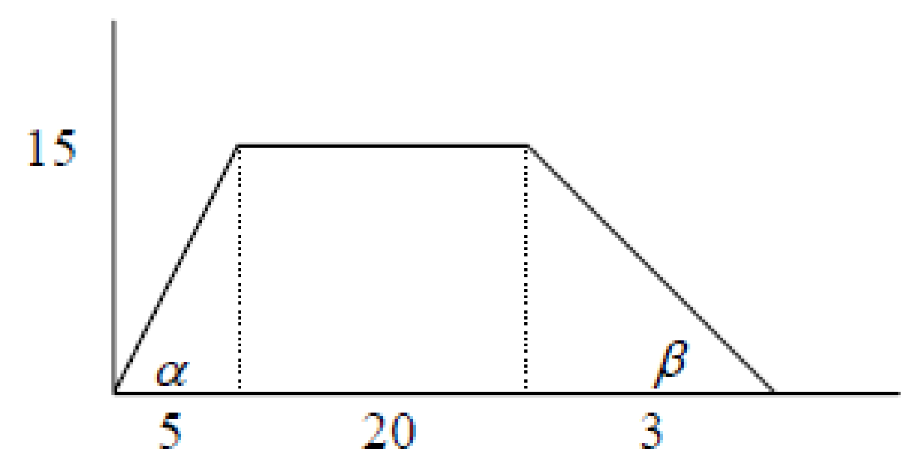
Solution
- See diagram

- v = u + at
15 = 0 + 5 a
a = 3 m s⁻²

- v = u + at
0 = 15 + 3a
a = - 5
deceleration is 5 m s⁻²

- distance = ½ (5)(15) + (20)(15) + ½ (3)(15)
= 37.5 + 300 + 22.5
= 360 m

- v² = u² + 2as
= 0 + 2(3)(13.5)
= 81 m
v = 9 m s⁻¹

Using the tan of the angle to calculate the acceleration
Alternative (and shorter) solution for answering parts (ii) and (iii)
- acceleration = slope = tan α = 15/5
acceleration = 3 m s⁻²
- deceleration = slope = tan β = 15/3
deceleration = 5 m s⁻²

Velocity-time graph: Car does not start from rest: Ordinary level Worked Solution

Note that in this case we need to break the first section into two sub-sections (a triangle and a rectangle) and get the area of each separately.

Alternatively, we could find the area of the first section in its entirety by considering it to be a trapezium (a quadrilateral with one pair of parallel sides) and use the formula: $Area=\left(\frac{a+b}{2}\right)h$ where a and b are the lengths of the two parallel sides.

2006 OL
A car travels along a straight level road.
It passes a point p at a speed of 10 m/s and accelerates uniformly for 5 seconds to a speed of 30 m/s.
It then moves at a constant speed of 30 m/s for 9 seconds.
Finally the car decelerates uniformly from 30 m/s to rest at point q in 6 seconds.
Find
  - the acceleration
  - the deceleration
  - pq , the distance from p to q
  - the average speed of the car as it travels from p to q.

Solution
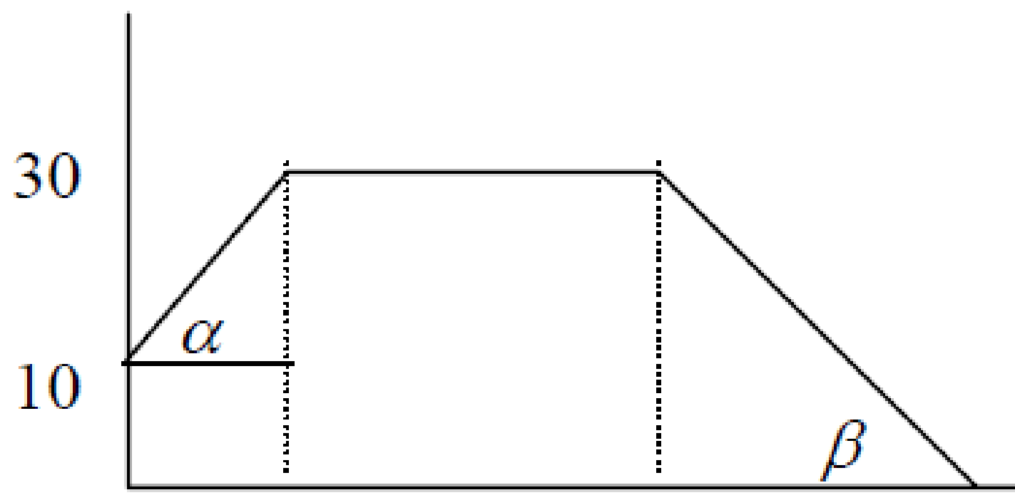
- Diagram:

- acceleration = tan α = 20/5 = 4 m s⁻²

- deceleration = tan β = 30/6 = 5 m s⁻²

- Distance from p to q
= 5(10) + ½ (5)(30-10) + (9)(30) + ½ (6)(30)
= 50 + 50 + 270 + 90
= 460 m

Note that we could also get the area of section A by using $\left(\frac{a+b}{2}\right)h$ = $\left(\frac{10+30}{2}\right)5$ = 100

- Average speed = total distance/total time = 460/20 = 23 m s⁻¹

Exam Questions Ordinary Level

2005 OL
A particle travels from p to q in a straight line. It starts from rest at p and accelerates uniformly to its maximum speed of 20 m/s in 10 seconds. The particle maintains this speed of 20 m/s for 15 seconds before decelerating uniformly to rest at q in a further 20 seconds.
- Draw a speed-time graph of the motion of the particle from p to q.
- Find the uniform acceleration of the particle.
- Find the uniform deceleration of the particle.
- Find ⏐pq⏐, the distance from p to q.
- Find the average speed of the particle as it moves from p to q, giving your answer in the form a/b where a, b ∈ N.

2012 OL
A car travels along a straight level road.
It passes a point P with a speed of 8 m s⁻¹ and accelerates uniformly for 12 seconds to a speed of 32 m s⁻¹.
It then travels at a constant speed of 32 m s⁻¹ for 7 seconds.
Finally the car decelerates uniformly from 32 m s⁻¹ to rest at a point Q.
The car travels 128 metres while decelerating.
Find
(i) the acceleration
(ii) the deceleration
(iii) |PQ|, the distance from P to Q
(iv) the speed of the car when it is 72 m from Q.

2010 OL
A car travels along a straight level road.
It passes a point P at a speed of 12 m s⁻¹ and accelerates uniformly for 6 seconds to a speed of 30 m s⁻¹.
It then travels at a constant speed of 30 m s⁻¹ for 15 seconds.
Finally the car decelerates uniformly from 30 m s⁻¹ to rest at a point Q.
The car travels 45 metres while decelerating.
Find
- the acceleration
- the deceleration
- |PQ|, the distance from P to Q
- the average speed of the car as it travels from P to Q

2006 OL
A car travels along a straight level road.
It passes a point p at a speed of 10 m/s and accelerates uniformly for 5 seconds to a speed of 30 m/s.
It then moves at a constant speed of 30 m/s for 9 seconds.
Finally the car decelerates uniformly from 30 m/s to rest at point q in 6 seconds.
Find
- the acceleration
- the deceleration
- pq , the distance from p to q
- the average speed of the car as it travels from p to q.

2011 OL
The points P and Q lie on a straight level road.
A car passes P with a speed of 10 m s⁻¹ and accelerates uniformly for 6 seconds to a speed of 22 m s⁻¹.
The car then decelerates uniformly to a speed of 18 m s⁻¹ and travels 80 m during this deceleration.
The car now maintains a constant speed of 18 m s⁻¹ for 3 seconds and then passes Q.
Find
- the acceleration
- the deceleration
- |PQ|, the distance from P to Q
- the average speed of the car, correct to one decimal place, as it moves from P to Q.

2013 OL
The points P and Q lie on a straight level road.
A car passes P with a speed of 28 m s⁻¹ and decelerates uniformly for 6 seconds to a speed of 16 m s⁻¹.
It then travels at a constant speed of 16 m s⁻¹ for 8 seconds.
The car now accelerates uniformly from 16 m s⁻¹ to a speed of 24 m s⁻¹ and then passes Q.
The car travels 40 metres while accelerating.
Find
- the deceleration
- the acceleration
- |PQ|, the distance from P to Q
- the speed of the car 12 seconds before it passes Q
- the average speed of the car between P and Q.

2014 OL
The points P and Q lie on a straight level road.
A car passes point P with a constant speed of 13 m s^{–1} and continues at this speed for 9 seconds.
The car then accelerates uniformly for 5 seconds to a speed of 28 m s^{–1}.
Finally the car decelerates uniformly from 28 m s^{–1} to rest at point Q.
The car travels 98 metres while decelerating.
(a) Draw a speed-time graph of the motion of the car from P to Q.

(b) Find
- the acceleration
- the deceleration
- |PQ|, the distance from P to Q
- the average speed of the car as it travels from P to Q, correct to two decimal places.

2002 OL
A train stops at stations P and Q which are 2000 metres apart.
The train accelerates uniformly from rest at P, reaching a speed of 20 m/s in 10 seconds.
The train maintains this speed of 20 m/s before decelerating uniformly at 0.5 m/s² , coming to rest at Q.
- Find the acceleration of the train.
- Find the time for which the train is decelerating.
- Find the distance and the time for which the train is travelling at constant speed.
- Draw an accurate speed-time graph of the motion of the train from P to Q.

Trickier ordinary level questions

The following questions have a tricky final part. They are still (obviously) ordinary level, but they act as a good guide to how you are likely to get on in this subject over the next two years. If you find that you need assistance with answering them then it doesn’t bode well for how you will fare at higher level. Better to find out now than in two years’ time.
They also offer a good indication of what Applied Maths is all about. The problem is supplied in English - you need to first figure out what they want you to do, then translate the problem into maths and figure out how to solve from there.

2004 OL
Three points a, b and c, lie on a straight level road such that ⏐ab⏐=⏐bc⏐= 100 m.
A car, travelling with uniform retardation, passes point a with a speed of 20 m/s and passes point b with a speed of 15 m/s.
- Find the uniform retardation of the car.
- Find the time it takes the car to travel from a to b, giving your answer as a fraction.
- Find the speed of the car as it passes c, giving your answer in the form p√q , where p, q ∈ N.
- How much further, after passing c, will the car travel before coming to rest?
Give your answer to the nearest metre.

2015 OL
The points P and Q lie on a straight level road.
A car passes P with a speed of 24 m s^{‒1} and decelerates uniformly for 4 seconds to a speed of 8 m s^{‒1}.
The car now accelerates uniformly from 8 m s^{‒1} to a speed of 26 m s^{‒1}.
The car travels 102 metres while accelerating.
It now continues at a constant speed of 26 m s^{‒1} for 10 seconds and then passes Q.

(a)
Find
- the deceleration
- the acceleration
- |PQ|, the distance from P to Q
- the average speed of the car between P and Q.

(b)
There is a legal speed limit of 100 km h^{‒1} on this road.
Investigate if the car exceeds the speed limit as it travels from P to Q.

2016 OL
The points P and Q lie on a straight level road.
A car travels along the road in the direction from P to Q.
It is initially moving with a uniform speed of 14 m s^{–1}.
As it passes P it accelerates uniformly for 8 seconds until it reaches a speed of 30 m s^{–1}.
Then the car decelerates uniformly from a speed of 30 m s^{–1} to a speed of 22 m s^{–1}.
The car travels 52 metres while decelerating.
It now continues at a constant speed of 22 m s^{–1} for 10 seconds and then passes Q.
(a) Draw a speed-time graph of the motion of the car from P to Q.

(b)
- Find the acceleration
- Find the deceleration
- Find |PQ|, the distance from P to Q
- Find the average speed of the car as it travels from P to Q
- Find the time for which the car is moving at or above its average speed.

Two-car problems

Useful points of information

- If acceleration is constant throughout then use equations of motion rather than a diagram

- $Average Speed=\frac{Total distance}{Total time}$.

Two cars: Ordinary level Worked Solution

2009 OL
3 points p, q and r lie on a straight level road.
Two cars, A and B, are moving towards each other on the road.
Car A passes p with speed 3 m/s and uniform acceleration of 2 m/s² and at the same instant car B passes r with speed 5 m/s and uniform acceleration of 4 m/s².
A and B pass each other at q seven seconds later.
Find
- the speed of car A and the speed of car B at q.
- |pq| and |rq|, the distances A and B have moved in these 7 s.
- Car A stops accelerating at q and continues on to r at uniform speed.
Find, correct to one place of decimals, the total time for car A to travel from p to r.

Solution
- v = u + at
v_{A} = 3 + 2(7)
v_{A} =17 m/s

v = u + at
v_{B} = 5 + 4(7)
v_{B} =33 m/s

- s = ut + ½ at²
s_{A} = 3(7) + ½ 2(49)
s_{A} =70 m

s = ut + ½ at²
s_{B} = 5(7) + ½ 4(49)
s_{B} =133 m

- s = ut + ½ at²
133 = 17(t) + 0
t = 7.8 s
total time = 14.8 s

Ordinary level Two-Car problems
2017 OL
The points P and Q lie on a straight level road.
A car passes P with a speed of 12 m s⁻¹ and accelerates uniformly for 4 seconds to a speed of 24 m s⁻¹.
It then travels at a constant speed of 24 m s⁻¹ for 14 seconds.
Finally, the car decelerates uniformly to rest at Q.
The car travels 72 metres while decelerating.

Find
- the acceleration
- the deceleration
- |PQ|, the distance from P to Q
- the average speed of the car as it travels from P to Q.

(b)
A van travels from P to Q and takes the same amount of time as the car.
The van starts from rest at P and accelerates uniformly to a maximum speed of k m s⁻¹.
It then decelerates uniformly to rest at Q.
- Draw a speed-time graph of the motion of the van from P to Q.
- Find the value of k.

2000 OL
A car is travelling on a straight stretch of level road [ pq ]. The car passes the point p with a speed of 5 m/s and accelerates uniformly to its maximum speed of 20 m/s in a time of
6 seconds. The car continues with this maximum speed for 30 seconds before decelerating uniformly to rest at q in a further 4 seconds.
- Draw a speed-time graph of the motion of the car from p to q.
Hence, or otherwise, find
- the uniform acceleration of the car
- the uniform deceleration of the car
- | pq | , the distance from p to q .

- Another car, with acceleration and deceleration the same as in (i) and (ii) above, starts from rest at p and accelerates uniformly to its maximum speed of 25 m/s. It continues with this maximum speed for a certain time and then decelerates uniformly to rest at q.
How long does it take this car to go from p to q?

2003 OL
A car travels from p to q on a straight level road. It passes p with a speed of 4 m/s and accelerates uniformly to its maximum speed of 8 m/s in 4 seconds. The car maintains this speed of 8 m/s for 6 seconds before decelerating uniformly to rest at q.
The car takes 12 seconds to travel from p to q.
- Draw a speed-time graph of the motion of the car from p to q.
- Find the uniform acceleration of the car.
- Find the uniform deceleration of the car.
- Find ⏐pq⏐, the distance from p to q.

- Another car travels the same distance from p to q in the same time of 12 seconds.
This car starts from rest at p and accelerates uniformly to its maximum speed of v m/s and then immediately decelerates uniformly to rest at q.
Find v, the maximum speed of this car, giving your answer as a fraction.

2001 OL
Two points, p and q, lie on a straight stretch of level road.
Car A passes the point p with a speed of 2 m/s travelling towards q and accelerating uniformly at 2 m/s².
As car A passes p, car B passes the point q with a speed of 1 m/s travelling towards p and accelerating uniformly at 3 m/s² .
The two cars meet after 10 seconds.
- Find the speed of each car when they meet.
- Find the distance each car has travelled during these 10 seconds.

- Suppose now that the speed of car A when passing point p is u m/s instead of 2 m/s, while the speed of car B passing point q and the acceleration of each car remain unchanged.
If the time taken for the two cars to meet in this case is 8 seconds, find the value of u.

Sample paper OL Question 8
Pole 𝑃 and traffic lights 𝐿 lie 800 m apart on a straight level road, as in the diagram below.
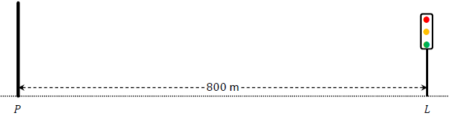
A car passes 𝑃 travelling towards 𝐿 with a speed of 5 m s^{–1} and an acceleration of 0.4 m s^{–2}.
At the same moment, a motorcycle passes 𝐿 travelling towards 𝑃 with a speed of 4 m s^{–1} and an acceleration of 0.6 m s^{–2}.

- Calculate the speed of the car 15 s after it passes 𝑃.
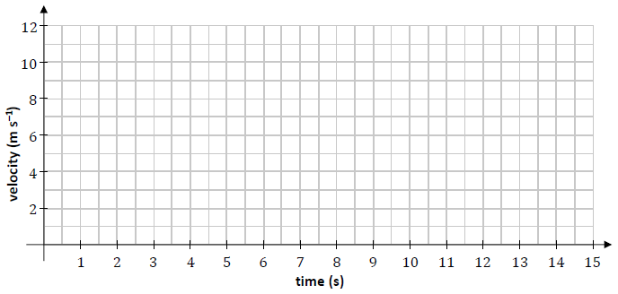
- Draw a velocity‐time graph for the motion of the car for the first 15 s after it passes 𝑃.

- Write an expression for 𝑠_{c}(𝑡), the displacement of the car from 𝑃 at any time 𝑡.
- Write an expression for 𝑠_{m}(𝑡), the displacement of the motorcycle from 𝐿 at any time 𝑡.
- The car and the motorcycle pass each other after 𝑇 seconds. Calculate 𝑇.
- At the instant that the car and motorcycle pass each other, the car stops accelerating and continues travelling at the velocity it has at that instant.
Calculate the total time it takes the car to travel from 𝑃 to 𝐿.

2023 OL Question 6
A car is parked at a point 𝑃. At time 𝑡 = 0 s the car begins to travel in a straight line with a constant acceleration of 4.5 m s^{–2}. When the car has reached a velocity of 18 m s^{–1} it stops accelerating. The car continues travelling at a velocity of 18 m s^{–1} until 𝑡 = 30 s.
- Calculate the time it takes for the car to reach 18 m s^{–1}.
- Calculate the distance travelled by the car while it is accelerating.
- Calculate the distance travelled by the car when 𝑡 = 30 s.

At 𝑡 = 0 a cyclist passed the car while travelling with a velocity of 8.5 m s^{–1} and an acceleration of 0.5 m s^{–2}. The cyclist accelerated until he reached a velocity of 11 m s^{–1}, which he then maintained.
- Calculate the time taken for the cyclist to reach a velocity of 11 m s^{–1}.
- Using the axes below, draw an accurate velocity‐time graph showing the motion of the car and the motion of the cyclist for the first 30 s of their motion.
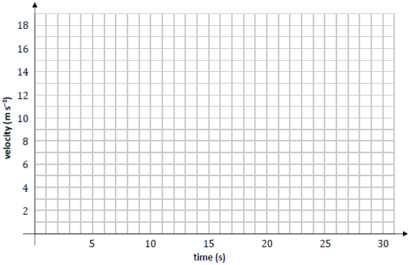
- Calculate the distance between the car and the cyclist when 𝑡 = 20 s.

Higher level Two-Car problems

[We just do a few of these in fifth year as a taster; the remainder are covered in sixth year]

Useful points of information

- If acceleration is constant throughout then use equations of motion rather than a diagram

- $Average Speed=\frac{Total distance}{Total time}$.

- ‘Retardation’ is another word for ‘deceleration’.

- Power = force × velocity

- Man just catches bus
A man runs after a bus and just catches it.
Key: v_{Man} = v_{Bus}. Why? It’s the word Just that’s crucial here. If the man was going quicker than the bus when he got up to it then you wouldn’t use the term “he just caught it”. On the other hand if the man was going slower than the bus then he wouldn’t catch up with it at all (at all).

- Greatest gap
The greatest gap between them also occurs when v_{man} = v_{Bus} (because if their speeds are unequal then the gap is either increasing or decreasing).
Another way of solving this is getting an expression for the distance between them (s_{Bus} – s_{man}) and then differentiating and letting the answer = 0. i.e. d(s_{Bus} – s_{man})/dt = 0.

- If A is in front of B at a certain time, then when they do meet we can say that s_{B} = s_{A} + gap

2014 (a)
Two cars, P and Q, travel with the same constant velocity 15 m s^{–1} along a straight level road.
The front of car P is 24 m behind the rear of car Q.
At a given instant both cars decelerate, P at 4 m s^{–2} and Q at 5 m s^{–2}.
- Find, in terms of t, the distance between the cars t seconds later.
- Find the distance between the cars when they are at rest.

2008 (b)
Two particles P and Q, each having constant acceleration, are moving in the same direction along parallel lines. When P passes Q the speeds are 23 m/s and 5.5 m/s, respectively.
Two minutes later Q passes P, and Q is then moving at 65.5 m/s.
- Find the acceleration of P and the acceleration of Q
- Find the speed of P when Q overtakes it
- Find the distance P is ahead of Q when they are moving with equal speeds.

2022 Deferred paper 1 (a)
Two cars, A and B, travel along a straight level road in opposite directions.
A passes point P with speed 4 m s⁻¹ and uniform acceleration 2 m s⁻².
Three seconds later B passes point Q with speed 5 m s⁻¹ and uniform acceleration 4 m s⁻².
The distance from P to Q is 1143 m.
The cars meet t seconds after A passes P.
Find the value of t.
Find the distance from P to the meeting point.
Find the distance between the cars when A is 160 m from the meeting point, before the cars meet.

2020 (a)
A car is travelling on a straight level road at a uniform speed of 26 m s^{–1} when the driver notices a tractor 91.2 m ahead.
The tractor is travelling at a uniform speed of 6 m s^{–1} in the same direction as the car.
The driver of the car hesitates for t seconds before applying the brake.
The maximum deceleration of the car is 5 m s^{–2}.
Find the maximum value of t which would avoid a collision between the car and the tractor.

2005 (a)
Car A and car B travel in the same direction along a horizontal straight road.
Each car is travelling at a uniform speed of 20 m/s.
Car A is at a distance of d metres in front of car B.
At a certain instant car A starts to brake with a constant retardation of 6 m/s².
0.5 s later car B starts to brake with a constant retardation of 3 m/s².
- Find the distance travelled by car A before it comes to rest
- Find the minimum value of d for car B not to collide with car A.

2015 (b)
A train of length 66.5 m is travelling with uniform acceleration $\frac{4}{7}$ m s^{–2}.
It meets another train of length 91 m travelling on a parallel track in the opposite direction with uniform acceleration $\frac{8}{7}$ m s^{–2}.
Their speeds at this moment are 18 m s^{–1} and 24 m s^{–1} respectively.
- Find the time taken for the trains to pass each other.
- Find the distance between the trains 1 second later.

2012 (b)
A car, starts from rest at A, and accelerates uniformly at 1 m s⁻² along a straight level road towards B, where │AB│ = 1914 m.
When the car reaches its maximum speed of 32 m s⁻¹, it continues at this speed for the rest of the journey.

At the same time as the car starts from A, a bus passes B travelling towards A with a constant speed of 36 m s⁻¹.
Twelve seconds later the bus starts to decelerate uniformly at 0·75 m s⁻².
- The car and the bus meet after t seconds. Find the value of t.
- Find the distance between the car and the bus after 48 seconds

2018 (b)
A car C moves with uniform acceleration a from rest to a maximum speed u.
It then travels at uniform speed u.
Just as car C starts, it is overtaken by a car D moving in the same direction with constant speed $\frac{3u}{4}$.
Car C catches up with car D when car C has travelled a distance d.
- Show that, at the instant car C catches up with car D, car C has been travelling with speed u for a time $\frac{4d}{3u}-\frac{u}{a}$.
- Find d in terms of u and a.

2019 (b)
Train A and Train B are on parallel tracks and travelling in opposite directions.
Train A starts from rest at Maynooth and accelerates uniformly at 0∙5 m s^{–2} towards Leixlip to a speed of 25 m s^{–1}. It then continues at this constant speed.

At the same instant as train A is leaving Maynooth Train B passes through Leixlip heading towards Maynooth at a constant speed of 30 m s^{–1}.
Three minutes after leaving Leixlip train B starts to decelerate at 0∙25 m s^{–2} and comes to rest at Maynooth.
- Find the distance between Maynooth and Leixlip.
- At what distance from Maynooth do the trains meet?
- After travelling at 25 m s^{–1} for a time, train A decelerates and comes to rest at Leixlip 36 seconds after train B stops at Maynooth. Find the deceleration of train A.

Sample Paper HL Question 3 (b)
Two athletes, Brian and Clara, are taking part in a relay race. Brian is preparing to hand over the baton to Clara. During the hand‐over of the baton the athletes need to be running in the same straight line and at the same velocity.
As Brian approaches Clara’s position at a constant speed of 11 m s^{–1}, Clara starts running from rest with constant acceleration 𝑓.
A short time later Brian begins to decelerate at 2 m s^{–2}.
Clara receives the baton 2.5 s after she starts running.
The baton is exchanged when Clara is 75 cm ahead of Brian and when both athletes have a speed of 8 m s^{–1}.
After the baton is exchanged, Brian continues to decelerate at 2 m s^{–2} until he comes to rest.
Clara continues to accelerate at 𝑓 until she reaches her maximum speed of 12 m s^{–1}, which she then maintains.
- Calculate the time it takes for Brian to decelerate before he exchanges the baton.

- Using the axes below, draw an accurate velocity‐time graph for the motion of each runner.
Time is measured from the instant that Clara begins to run.
Relevant calculations should be shown in the space below.
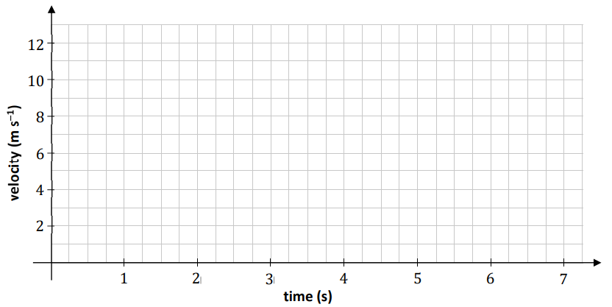

- Calculate the distance between the two athletes when Clara begins to run.

2023 HL Question 5 (b)
Áine travels by car from her house to work each morning.
On Monday morning she starts her car and accelerates uniformly for 40 s to a speed of 22.5 m s^{–1}.
Áine then travels at this speed for 8 minutes until decelerating uniformly to rest at her work.
She reaches her work at exactly 08: 30.
On Tuesday morning Áine leaves her house 140 s later than the day before.
She takes the same route to work.
She starts her car and accelerates at 1.5 m s^{–2} for 20 s, then maintains this steady speed for 6 minutes before decelerating uniformly to rest at her work.
She again reaches her work at exactly 08: 30.
Calculate the time when Áine leaves her house on Tuesday morning.

2021 (b)
Car C, moving with uniform acceleration f passes a point P with speed u (> 0).
Two seconds later car D moving in the same direction with uniform acceleration 2f passes P with speed $\frac{6}{5}$ u.
C and D pass a point Q together.
The speeds of C and D at Q are 6.5 m s^{–1} and 9 m s^{–1} respectively.
- Show that C travels from P to Q in ($\frac{3}{2f}$+ 5) seconds.
- Find the value of f.

2010 (a)
A car is travelling at a uniform speed of 14 m s⁻¹ when the driver notices a traffic light turning red 98 m ahead.
Find the minimum constant deceleration required to stop the car at the traffic light,
- if the driver immediately applies the brake
- if the driver hesitates for 1 second before applying the brake.

2000 (b)
A car, starting from rest and travelling from p to q on a straight level road, where ⏐pq ⏐= 10 000 m, reaches its maximum speed 25 m/s by constant acceleration in the first 500 m and continues at this maximum speed for the rest of the journey.
A second car, starting from rest and travelling from q to p, reaches the same maximum speed by constant acceleration in the first 250 m and continues at this maximum speed for the rest of the journey.
- If the two cars start at the same time, after how many seconds do the two cars meet?
- Find, also, the distance travelled by each car in that time.
- The start of one car is delayed so that they meet each other exactly halfway between p and q, find which car is delayed and by how many seconds.

1998 (b)
Car A, moving with uniform acceleration $\frac{3b}{20}$ m/s² passes a point p with speed 9u m/s. Three seconds later Car B, moving with uniform acceleration $\frac{2b}{9}$ m/s² passes the same point with speed 5u m/s. B overtakes A when their speeds are 6.5 m/s and 5.4 m/s respectively.
Find
- the value of u and the value of b.
- the distance travelled from p until overtaking occurs.

1997 (b)
Two points p and q are a distance d apart. A particle starts from p and moves towards q with initial velocity 2u and uniform acceleration f. A second particle starts at the same time from q and moves towards p with initial velocity 3u and uniform deceleration f . Prove that
- the particles collide after $\frac{d}{5u}$seconds
- if the particles collide before the second particle comes to instantaneous rest, then fd < 15u²
- if fd = 30u² then the second particle has returned to q before the collision.

1992 (b)
Two particles P and Q are moving in the same direction along parallel straight lines.
Their accelerations are 5 m/s² and 4 m/s², respectively.
At a certain instant P has a velocity 1 m/s and Q is 25.5 m behind P moving with velocity 11 m/s.
- Prove that Q will overtake P and that P will in turn overtake Q.
- When Q is in front of P find the greatest distance between the particles.

2003 (b)
A man runs at constant speed to catch a bus. At the instant the man is 40 metres from the bus, it begins to accelerate uniformly from rest away from him. The man just catches the bus 20 seconds later.
- Find the constant speed of the man.
- If the constant speed of the man had instead been 3 m/s, show that the closest he gets to the bus is 17.5 metres.

1977
A car starts from rest at P and moves with constant acceleration k m/s².
Three seconds later another car passes through P travelling in the same direction with constant speed u m/s, where u > 3k.
- Draw a velocity/time graph for the two cars, using the same axes and the same scales.
- Hence or otherwise, show that the second car will just catch up on the first if u = 6k and that it will not catch up on it if u < 6k.
- If u > 6k, find the greatest distance the second car will be ahead of the first.

1978 (a)
Two particles A and B are moving along two perpendicular lines towards a point O with constant velocities of 1.2 m/s and 1.6 m/s respectively.
When A is 12 metres from O, B is 20 metres from O.
Find the distance between them when they are nearest to each other.

1987 (b)
A car, A, starts from a point p with initial velocity of 8 m/s and then travels with a uniform acceleration of 4 m/s².
Two seconds later a second car B starts from p with an initial velocity of 30 m/s and then moves with a uniform acceleration of 3 m/s².
Show that after passing A, B will never be ahead by more than 74 m.

2006 (b)
Two trains P and Q, each of length 79.5 m, moving in opposite directions along parallel lines, meet at o, when their speeds are 15 m/s and 10 m/s respectively.
The acceleration of P is 0.3 m/s² and the acceleration of Q is 0.2 m/s².
It takes the trains t seconds to pass each other.
- Find the distance travelled by each train in t seconds.
- Hence, or otherwise, calculate the value of t.
- How long does it take for 2/5 of the length of train Q to pass the point o?

1989
Two cars A and B, each 5 m in length, travel with constant velocity 20 m/s along a straight level road.
The front of car A is 15 m directly behind the rear of car B.
Immediately on reaching a point P each car decelerates at 4 m/s².
- Show that A collides with B.
- At what distance from P does the collision occur?
- Show the motion of both cars on the same speed-time graph.

1986 (a)
A particle with speed 150 m/s begins to decelerate uniformly at a certain instant while another particle starts from rest 8 s later and accelerates uniformly.
When the second particle had travelled 135 m both particles have a speed of 30 m/s.
- Show the motion of both particles on the same speed-time graph.
- How many seconds after the commencement of deceleration does the first particle come to rest?

1982 (a)
A car A passes a point p on a straight road at a constant speed of 10 m/s.
At the same time another car B starts from rest at p with uniform acceleration 2.5 m/s².
- When and how far from p will B overtake A?
- If B ceases to accelerate on overtaking, what time elapses between the two cars passing a point q three kilometres from p?

1976
Show that, if a particle is moving in a straight line with constant acceleration k and initial speed u, then the distance travelled in time t is given by s = ut + ½ kt ².
Two points a and b are a distance l apart.
A particle starts from a and moves towards b in a straight line with initial velocity u and constant acceleration k.
A second particle starts at the same time from b and moves towards a with initial velocity u and constant deceleration k.
Find the time in terms of u, l, at which the particles collide, and the condition satisfied by u, k, l, if this occurs before the second particle returns to b.

1971
Explain how a graph of velocity plotted against time can be used to calculate acceleration and distance travelled, with particular reference to motion with constant acceleration.

A pigeon in flight releases a small stone from its beak at a height of 50 metres when its velocity is u. If the stone takes 3½ seconds to reach the ground, show that the direction of u is not horizontal and compute the greatest height reached by the stone after release.
(Give your answer correct to the nearest tenth or 0·1 of a metre.)

Vertical motion (all Higher Level)

Introduction

Acceleration due to gravity (‘g’)

In the absence of air resistance, all objects near the earth’s surface will fall with the same acceleration.
This acceleration is called acceleration due to gravity. Its symbol is ‘g’.
The value of g on the surface of the earth is 9.8 m s⁻².
We mention ‘on the surface of the earth’ because the value of g decreases as you move further away from the surface. We can now use this value when using equations of motion.

Notes
- Because we take the upward direction as positive, and because g is acting downwards, we take g to be minus (-) 9.8 m s⁻² when answering maths questions (i.e. the initial velocity is usually opposite in direction to acceleration).
- If an object is released from rest it means that initial velocity is 0 (u = 0).
- At the highest point of a trajectory, the (instantaneous) velocity is zero (object is not moving upwards or downwards).
- At the highest point of the trajectory object is still accelerating at 9.8 m s⁻² (even though the instantaneous velocity is zero).

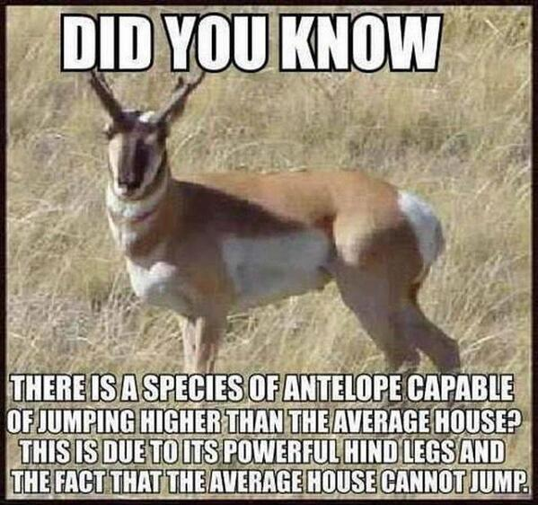

Why do we take g as negative (-9.8) for the entire motion of the particle (up and down)?
Students associate the direction of acceleration with the direction that the particle is moving in.
This is very understandable as up to to now their only experience of acceleration is probably a speeding car, where velocity and acceleration are indeed in the same direction.
For this concept I take time to explain that you can only have an acceleration if you have a force to cause the acceleration, and because the acceleration is the consequence of this force, it stands to reason that the direction of the acceleration is the same as the direction of the force.

So the direction the object is moving in is actually a complete red herring, and the sooner they grasp this the better.
It's also why, if a stone is whirled around at the end of a string in a circular motion, the acceleration of the stone is actually in towards the centre of the circle (because that's the direction of the force (tension in the string) acting on it.

Another reason they may associate acceleration with velocity is because we often 'define' acceleration as: a= (v-u/t)

This is a mathematical relationship that allows us to calculate a mathematical value for the acceleration, but that's all.

How can the equation get away with not taking the distance travelled into account?
OR
Why doesn't s represent the distance travelled?

The equations are derived from a conservation of energy perspective, and for this we only need to note that total energy at the beginning must equal total energy at the end, regardless of where the particle has gone in between those two stages.

Vertical motion short exam questions taken from Physics papers
- [2005]
A basketball which was resting on a hoop falls to the ground 3.05 m below.
What is the maximum velocity of the ball as it falls?

- [2006 OL]
An astronaut drops an object from a height of 1.6 m above the surface of the moon and the object takes 1.4 s to fall. Calculate the acceleration due to gravity on the surface of the moon.

- [2003 OL]
- An astronaut is on the surface of the moon, where the acceleration due to gravity is 1.6 m s^{–2}.
The astronaut throws a stone straight up from the surface of the moon with an initial speed of 25 m s^{–1}. Describe how the speed of the stone changes as it reaches its highest point.
- Calculate the highest point reached by the stone.
- Calculate how high the astronaut can throw the same stone with the same initial speed of 25 m s^{–1} when on the surface of the earth, where the acceleration due to gravity is 9.8 m s^{–2}.

- [2003]
A skydiver falls from an aircraft that is flying horizontally. He reaches a constant speed of 50 m s^{–1} after falling through a height of 1500 m. Calculate the average vertical acceleration of the skydiver.

- [2006]
A student releases a ball when is 130 cm above the ground and the ball travels vertically upwards with an initial velocity of 7 m s⁻¹.
Calculate the maximum height, above the ground, the ball will reach.

Solutions

- v² = u² +2as ⇒ v² = 0 + 2(9.8)(3.05) ⇒ v² = 59.78
v = 7.73 m s⁻¹

- s = 1.6 m, t = 1.4 s, u = 0. Substitute into the equation s = ut + ½ at² to get a = 1.6 m s⁻².

- It slows until at the very top it’s speed is 0.
- v² = u² + 2as ⇒ 0 = (25)² + 2 (-1.6) s ⇒ s = 195.3 m.
- v² = u² + 2as ⇒ 0 = (25)² + 2 (-9.8) s ⇒ s = 31.9 m.

- v ²= u²+2as ⇒ 50² = 0 + (2)(a)(1500) ⇒ a = 0.83 m s⁻²

- v² = u²+ 2as ⇒ 0 = (7)² + 2(-9.8) s / s = 2.5(0) m ⇒ max. height = 2.5 + 1.30 / 3.8 m

Vertical motion Applied Maths worked solution

2002 (a) {part (i) only}
A stone is thrown vertically upwards under gravity with a speed of u m/s from a point 30 m above the horizontal ground.
The stone hits the ground 5 seconds later.
Find the value of u

Solution
Step 1: pick the appropriate equation and sub in the values:
s = ut + ½ at²
30 = (u)(5) + 1/2 (9.8)(5²)

Now we need to acknowledge that some of these vectors are acting in different directions.
So let’s take the upward direction as positive:

- 30 is displacement, and the ball finishes below where it started so this number becomes negative.
- We're looking for u, so we leave this as is (but it should end up as a positive number because we are told that the initial velocity is upwards).
- g acts downwards therefore this needs to be negative.

-30 = (u)(5) + ½ (-9.8)(5²)
We can put the negative sign in front of the ½ so we get:
-30 = (u)(5) - ½ (9.8)(5²)

Answer: u = + 18.5 m s⁻¹

Why are s and g negative?
Each of the 5 vuast variables are vectors - so direction is significant, and the direction of each individual vector is indicated by the sign in front of the number. If there's no number in front then the assumption is that the number is positive.

If we wished we could repeat the exercise taking the downward direction as positive.
All the signs change, so hopefully you can see that this is the same as multiplying the original equation by minus 1.
Obviously you wouldn't show both options for every question, but it is certainly worthwhile doing it once as a teacher, and referring back to it in future questions.
So the question I ask all the time is "Is g positive or negative in this question?" and I keep asking it until everybody knows that the correct answer is "It depends" and they also obviously need to be able to explain why (it depends on the convention I am choosing to go with for this particular question. In fact it's not for this particular question - it's for this particular equation. You are quite entitled to change conventions for another equation within the same question, once you're consistent within the equation itself).

It is essential that you understand this as it comes up time and time again throughout the course.

Vertical motion Applied Maths exam questions

2008 (a)
A ball is thrown vertically upwards with an initial velocity of 39.2 m/s.
- Find the time taken to reach the maximum height
- Find the distance travelled in 5 seconds.

2013 (a)
A ball is thrown vertically upwards with a speed of 44·1 m s⁻¹.
Calculate the time interval between the instants that the ball is 39·2 m above the point of projection.

2002 (a)
A stone is thrown vertically upwards under gravity with a speed of u m/s from a point 30 metres above the horizontal ground. The stone hits the ground 5 seconds later.
- Find the value of u.
- Find the speed with which the stone hits the ground.

And one more time for the students at the back - When do we use a minus sign?

If we have two vectors quantities (eg initial velocity and acceleration) and they are in different directions then we need to acknowledge this every time we substitute their value into an equation. We this by ‘making’ one number positive and the other one negative. Strictly speaking it doesn’t matter which way we do it but we normally take the one acting upwards to be positive – which is why we take ‘g’ to be negative.
If we have three quantities (eg initial velocity, acceleration and displacement) then the quantities acting in the same direction must have the same sign.

Classic exam question – camera dropped from a hot-air balloon
1992 (a) {adapted}
The following question is very useful for highlighting the importance of having a sign convention when answering a question.

A hot-air balloon ascends vertically at a uniform speed.
7.2 seconds after it leaves the ground a passenger on the balloon-ride drops her camera from the balloon.
The particle takes 9 seconds to reach the ground.
Calculate the height from which the camera was dropped.

Common initial velocity

Here we are given information on two sections of an object’s travel; the first is from the beginning, and another section is straight after.
We need to get an equation for both and solve, but to do this the variables (particularly u) must represent the same number for both equations.
The only way to do this is to make the second equation represent the first two sections, i.e. bring it back to the beginning. This means the distance s must be the distance from the beginning.

Note that these questions can involve either vertical or horizontal motion

2000 (a)
A stone projected vertically upwards with an initial speed of u m/s rises 70 m in the first t seconds and another 50 m in the next t seconds. Find the value of u.

1988 (b)
A particle falls from rest from a point o, passing three points a, b, and c, the distances ab and bc being equal. If the particle takes 3 seconds to pass from a to b and 2 seconds from b to c, calculate |ab|.

1996 (a)
A particle starts from rest and moves in a straight line with uniform acceleration.
It passes three points a, b and c where |ab| = 105m and |bc| = 63m.
If it takes 6 seconds to travel from a to b and 2 seconds to travel from b to c find
- its acceleration
- the distance of a from the starting position.

1993 (a)
A particle moving in a straight line travels 30 m, 54 m and 51 m in successive intervals of 4, 3 and 2 seconds.
- Verify that the particle is moving with uniform acceleration
- Draw an accurate speed-time graph of the motion.

1974
A sprinter runs a race with constant acceleration k throughout.
During the race he passes four posts a, b, c, d in a straight line such that |ab| = |bc| = |cd| = 36 m.
If the sprinter takes 3 seconds to run from a to b and 2 seconds to run from b to c, find how long, to the nearest tenth of a second, it takes him to run from c to d.

2003 (a)
The points p, q and r all lie in a straight line.
A train passes point p with speed u m/s.
The train is travelling with uniform retardation f m/s².
The train takes 10 seconds to travel from p to q and 15 seconds to travel from q to r, where | pq| = | qr | = 125 metres.
- Show that f =
- The train comes to rest s metres after passing r. Find s, giving your answer correct to the nearest metre.

2021 (a)
A ball is thrown vertically downwards from the top of a building of height h m.
The ball passes the top half of the building in 1.2 s and takes a further 0.8 s to reach the bottom of the building.

Find
- the value of h
- the speed of the ball at the bottom of the building.

2017 (a)
A car passes four collinear markers A, B, C, and D while moving in a straight line with uniform acceleration. The car takes t seconds to travel from A to B, t seconds to travel from B to C and t seconds to travel from C to D.
If |AB| + |CD| = k|BC|, find the value of k.

2002 (b) difficult leave this until sixth year
A particle, with initial speed u, moves in a straight line with constant acceleration.
During the time interval from 0 to t, the particle travels a distance p.
During the time interval from t to 2t, the particle travels a distance q.
During the time interval from 2t to 3t, the particle travels a distance r.
Show that 2q = p + r.
Show that the particle travels a further distance 2r − q in the time interval from 3t to 4t.

Slight Variations
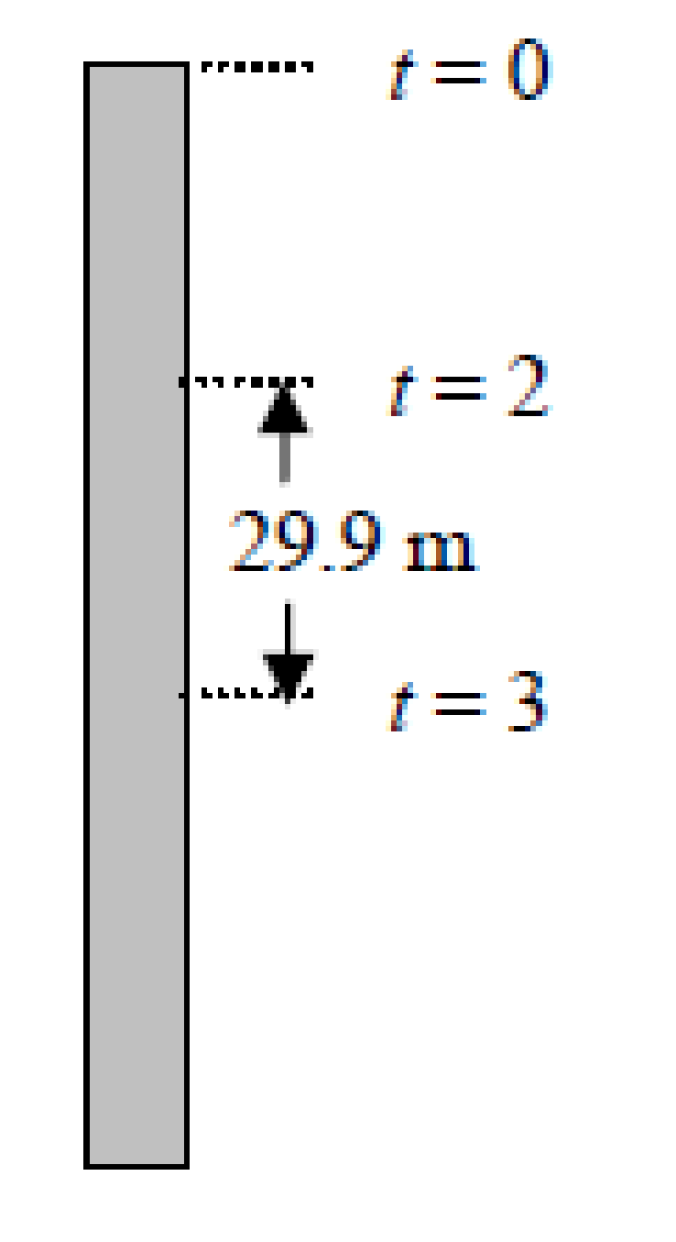
These seem tricky, but the procedure is your friend; pick two stages which have the same two unknowns and solve.

2007 (a)
A particle is projected vertically downwards from the top of a tower with speed u m/s.
It takes the particle 4 seconds to reach the bottom of the tower.
During the third second of its motion the particle travels 29.9 metres.
Find
- the value of u
- the height of the tower.

2011 (a)
A particle is released from rest at A and falls vertically passing two points B and C.
It reaches B after t seconds and takes $\frac{2t}{7}$ seconds to fall from B to C, a distance of 2.45 m.
Find the value of t.

2022 Deferred paper 1 (b)
An object falls vertically, from rest, from a height h metres. It travels $\frac{15}{64}h$ metres during its final second of motion before hitting the ground.
Find the time it takes to fall to the ground.
Find the value of h.

1986 (b) – just set up equations in Fifth year
A particle starting from rest at p moves in a straight line to q with uniform acceleration.
In the first second it travels 5 m.
In the last three seconds of its motion before reaching q it travels 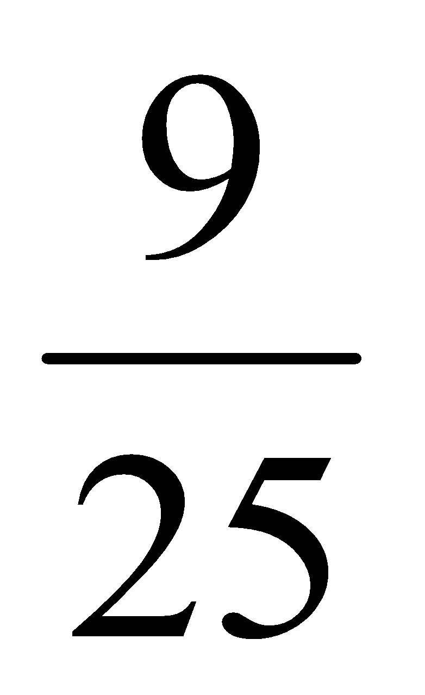 of |pq|.
Find the time in seconds from p to q.

2010 (b) - just set up equations in Fifth Year
A particle passes P with speed 20 ms⁻¹ and moves in a straight line to Q with uniform acceleration.
In the first second of its motion after passing P it travels 25 m.
In the last 3 seconds of its motion before reaching Q it travels $\frac{13}{20}$ of ⏐PQ⏐.
Find the distance from P to Q.

Leave the questions below until Sixth Year
2015 (a)
A particle starts from rest and moves with constant acceleration.
If the particle travels 39 m in the seventh second, find the distance travelled in the tenth second.

1988 (a)
A particle moving in a straight line with uniform acceleration describes 23 m in the fifth second of its motion and 31 m in the seventh second.
Calculate its initial velocity.

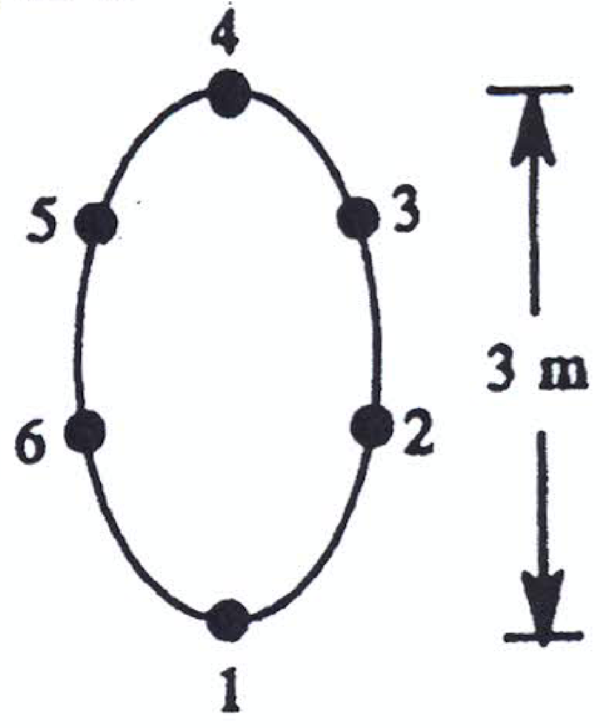
1995 (b)
A juggler throws up six balls, one after the other at equal intervals of time t, each to a height of 3 m.
The first ball returns to his hand t seconds after the sixth was thrown up and is immediately thrown to the same height, and so on continually.
(Assume that each ball moves vertically).
Find
- the initial velocity of each ball.
- the time t.
- the heights of the other balls when any one reaches the juggler’s hand.

Collisions

- At the point of collision s₁ = s₂ so get an equation for s₁ and s₂ (using s = ut + ½ at²).
Then equate the two equations and solve.

- A final note on the distinction between distance and displacement (for vertical motion).
On the way up, distance and displacement will be the same, but not when the ball is coming down (distance is total distance travelled, while displacement is only the height above the ground).

Note that in our equations of motion s always corresponds to displacement, not distance.

- If you are asked for the distance that the ball travelled when collision occurred you will first have to establish whether the ball was on the way up or on the way down at that point.
The easiest way to establish whether the ball was on the way up or the way down is to compare the time to reach maximum height to the time of collision, e.g. if the collision occurred after 5 seconds and the time to reach maximum height was 6 seconds the ball never reached the top and so was travelling up when collision occurred.

If the collision happened when the ball was on the way up then distance travelled equals s.

- If the collision happened when the ball was on the way down then to find distance travelled you have to break the problem up into two parts; distance from point of projection to top of the trajectory plus distance from top of trajectory to the point of collision on the way down.

- Concept of t and (t+2)
Ball A is thrown up into the air and two seconds later ball B is thrown up. The balls collide after a further t seconds.
Key: For the collision, A is in the air for t seconds and B is in the air for (t-2) seconds
Or
B is the air for t seconds and A is in the air for (t+2) seconds.
The second option is preferable because it’s easier to deal with ‘pluses’ than ‘minuses’.

- Instead of solving equations involving (t+2), you could simply let x = (t+2) and then solve as required. Just remember to note this in your worked solution.
And don’t forget to reverse the substitution at the end.

2004 (a)
A ball is thrown vertically upwards with an initial velocity of 20 m/s.
One second later, another ball is thrown vertically upwards from the same point with an initial velocity of u m/s.
The balls collide after a further 2 seconds.
- Show that u = 17.75.
- Find the distance travelled by each ball before the collision, giving your answers correct to the nearest metre. [part (i) is nice; part (ii) should probably be left for now and return to it later]

1975
A particle falls freely under gravity from rest at a point p.
After it has fallen for one second another particle is projected vertically downwards from p with a speed of 14.7 m/s.
By considering the relative motion of the particles, or otherwise, find the time and distance from p at which they collide.
Show the motion of both on a time-velocity graph.

1993 (b)
A particle P is projected vertically upwards from the ground with an initial velocity of 47 m/s.
Two seconds later another particle Q is projected vertically upwards from the same point with initial velocity 64.6 m/s.
Calculate
- how long Q is in motion before it collides with P.
- the height at which the collision occurs.

2012 (a)
A particle falls from rest from a point P.
When it has fallen a distance 19·6 m a second particle is projected vertically downwards from P with initial velocity 39·2 m s⁻¹.
The particles collide at a distance d from P.
Find the value of d.

1991 (b)
A particle P is projected vertically upwards with an initial velocity u and two seconds later a second particle Q is projected vertically upwards from the same point with initial velocity 1.5u.
Calculate, in terms of u, how long Q is in motion before it collides with P and prove that |u| > 9.8.

These are sufficient for our first run-through on this section

The next few questions are all a bit trickier (but feel free to try them if you wish)

2016 (b)
A particle is projected vertically upwards with a velocity of u m s^{–1}.
After an interval of 2t seconds a second particle is projected vertically upwards from the same point and with the same initial velocity.
They meet at a height of h m.
Show that $h=\frac{u^{2}-g^{2}t^{2}}{2g}$

2022 (b)
A ball E is thrown vertically upwards with a speed of 42 m s^{–1}.
𝑇 (< 8) seconds later another ball, F, is thrown vertically upwards from the same point with the same initial speed.
- Find where ball E is after 5 s and the total distance it has travelled in this time.
- Prove that when E and F collide, they will each be travelling with speed ½𝑔𝑇.

2001 (b)
A particle is projected vertically upwards with an initial velocity of u m/s and another particle is projected vertically upwards from the same point and with the same initial velocity T seconds later.
- Show that the particles will meet (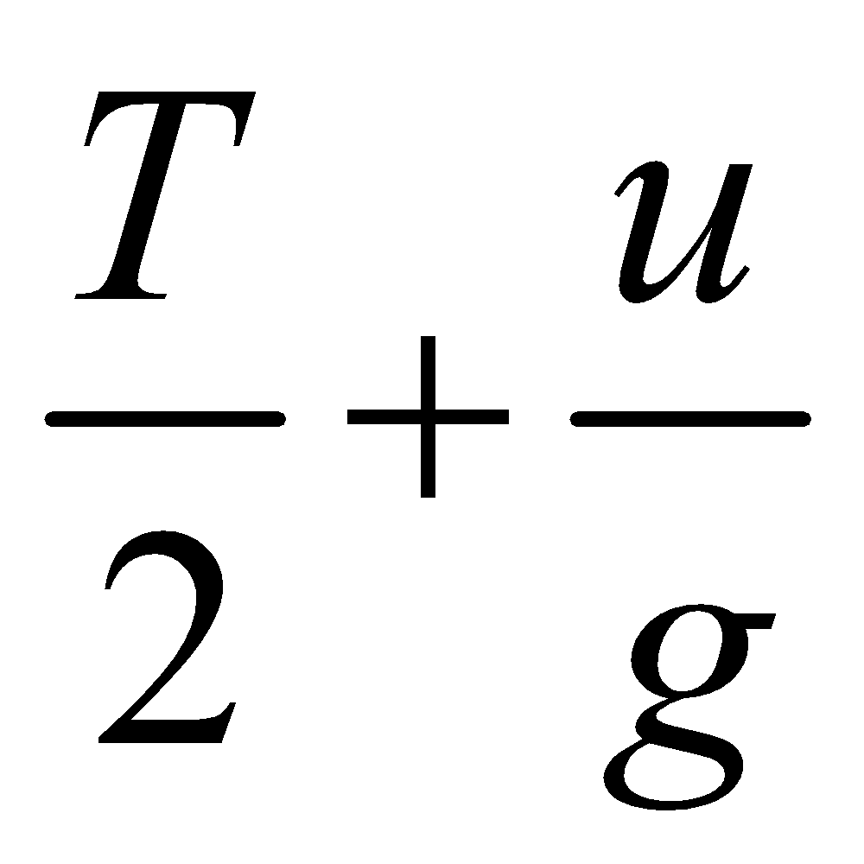) seconds from the instant of projection of the first particle
- Show that the particles will meet at a height of 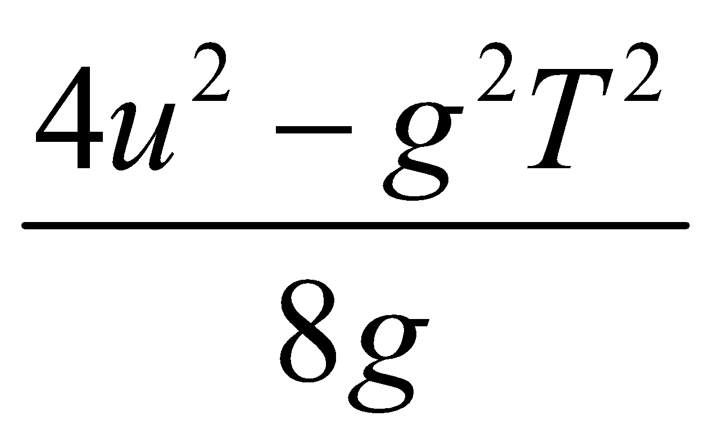 metres.

2009 (a)
A particle is projected vertically upwards from the point p.
At the same instant a second particle is let fall vertically from q.
The particles meet at r after 2 seconds.
The particles have equal speeds when they meet at r.
Prove that ⏐pr⏐ = 3⏐rq⏐.

Misc

1990 (a)
A particle is projected vertically upwards with velocity u m/s and is at a height h after t₁ and t₂ seconds respectively. Prove that t₁ . t₂ = 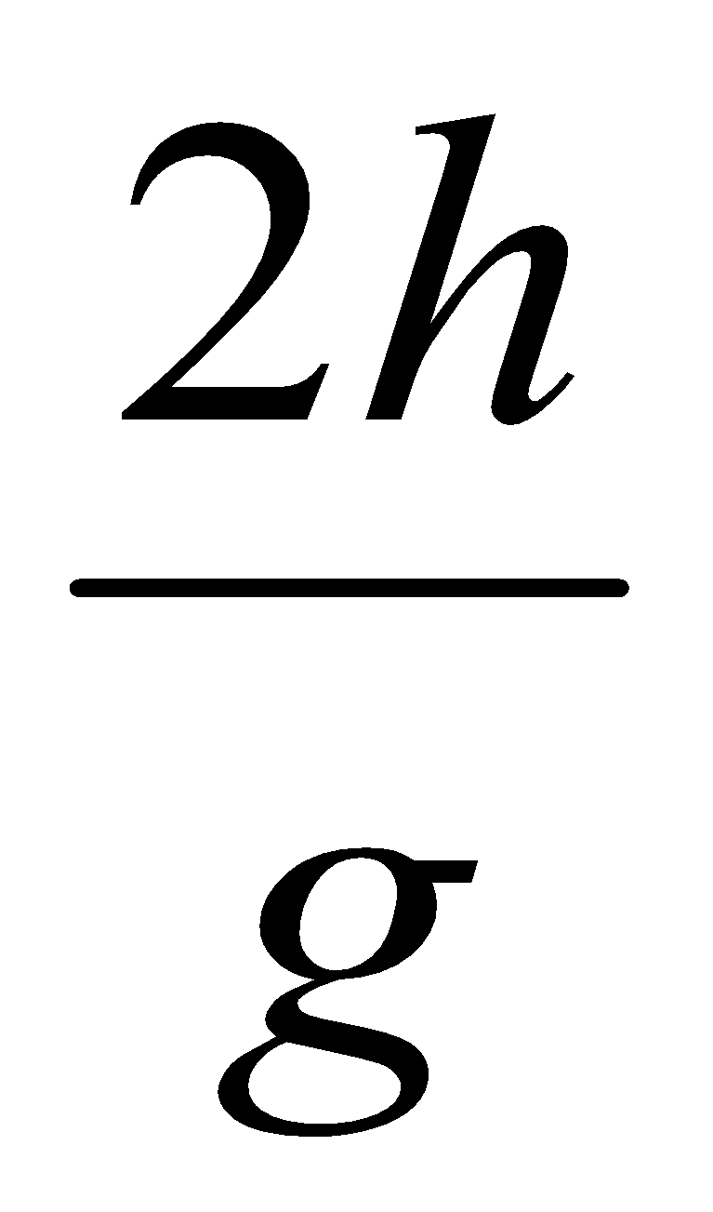

Velocity-time graphs

These can be quite tricky so usually we just do a couple of questions as an introduction in Fifth Year, and leave the remainder until Sixth Year.

Acceleration followed immediately by deceleration (“rest to rest”)

Introduction
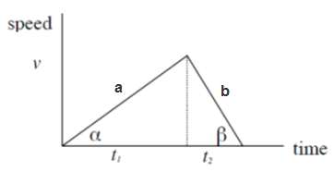
It can be shown, using the diagram and the equation v = u + at that

$$\frac{a}{b}= \frac{t_{2}}{t_{1}}$$

Let’s assume that we are told in a question that the deceleration is twice the acceleration.
This means:
- t₁ is twice t₂.
- t₁ is two thirds of the total time T. t₂ is one third of the total time T.
i.e. t₁ = $\frac{2T}{3}$ t₂ = $\frac{T}{3}$

The standard approach for these problems is as follows:
- Get an expression for v using v = u + at (from Stage 1).

- You will usually be given information about either the total distance or the total time.
Use the fact that the total area under the graph = total distance travelled.
So use S_{total} = ½ Tv to get a second equation.

- Solve simultaneous equations.

Acceleration followed immediately by deceleration exam questions

The trick is usually to look at two different sections and get an equation for each.
Try to minimise the number of variables.
Then solve.

1987 (a)
The maximum acceleration of a body is 4 m/s² and its maximum retardation is 8 m/s².
What is the shortest time in which the body can travel a distance of 1200 m from rest to rest?

2006 (a)
A lift starts from rest. For the first part of its descent it travels with uniform acceleration f.
It then travels with uniform retardation 3f and comes to rest.
The total distance travelled is d and the total time taken is t.
- Draw a speed-time graph for the motion.
- Find d in terms of f and t.

1994 (a)
A lift, in continuous descent, had uniform acceleration of 0.6 m/s² for the first part of its descent and a retardation of 0.8 m/s² for the remainder.
The time, from rest to rest, was 14 seconds. Draw a time-velocity graph and hence, or otherwise, find the distance descended.

2009 (b)
A train accelerates uniformly from rest to a speed v m/s with uniform acceleration f m/s².
It then decelerates uniformly to rest with uniform retardation 2f m/s².
The total distance travelled is d metres.
- Draw a speed-time graph for the motion of the train.
- If the average speed of the train for the whole journey is $\sqrt{\frac{d}{3}}$, find the value of f.

Sight variations

2001 (a)
Points p and q lie in a straight line, where |pq| = 1200 metres.
Starting from rest at p, a train accelerates at 1 m/s² until it reaches the speed limit of 20 m/s.
It continues at this speed of 20 m/s and then decelerates at 2 m/s², coming to rest at q.
- Find the time it takes the train to go from p to q.
- Find the shortest time it takes the train to go from rest at p to rest at q if there is no speed limit, assuming that the acceleration and deceleration remain unchanged at 1 m/s² and 2 m/s², respectively.

1973
A cyclist has a maximum acceleration of 2 m/s², a maximum speed of 15 m/s and a maximum deceleration of 4 m/s².
The cyclist wishes to travel a distance s from rest to rest in the shortest time.
Find the time taken in the two cases
- s =105 m
- s = 54 m.
Draw a rough velocity-time graph for each case and explain why 84³/₅ m is a critical distance

General velocity-time exam questions

Considering a velocity-time graph as a trapezoid
A trapezoid is a quadrilateral with one pair of opposite sides parallel.
The area of a trapezoid is given by the formula $Area=h(\frac{b_{1}+ b_{2}}{2})$

Many of our velocity-time graphs will be trapezoids so we can use the relationship below to express the total distance travelled in terms of total time (T) and time travelled at constant velocity (t₂).

Area of a trapezoid
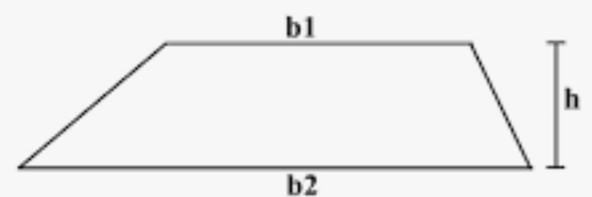 |  | 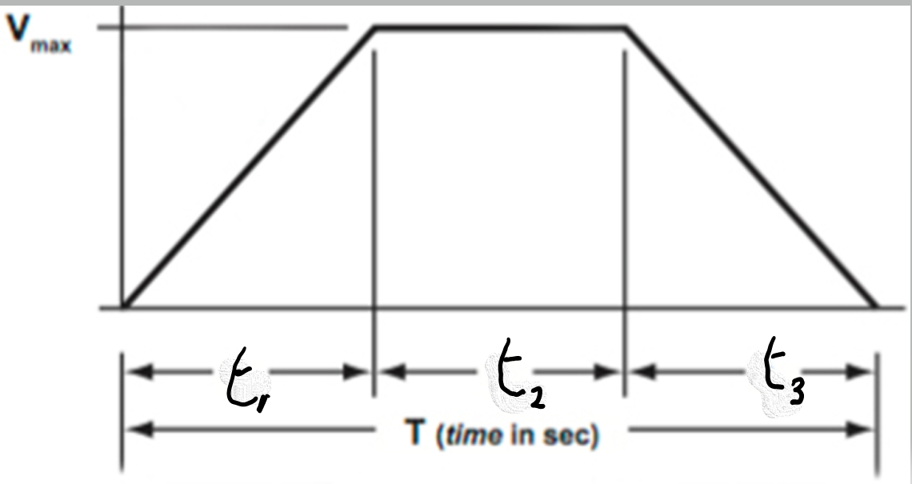
$$Area=h(\frac{b_{1}+ b_{2}}{2})$$ |  | $$Area=v_{max}(\frac{t_{2}+ T}{2})$$

1996 (b)
A lift starts from rest with constant acceleration 4m/s². It then travels with uniform speed and finally comes to rest with constant retardation 4 m/s². The total distance travelled is d and the total time taken is t.
- Draw a speed-time graph.
- Show that the time for which it travelled with uniform speed is $\sqrt{t^{2}-d}$

1979 (a)
How may a velocity-time graph be used to find the distance travelled in a given time?
An athlete runs 100 m in 12 seconds.
Starting from rest, he accelerates uniformly to a speed of 10 m/s, and then continues at that speed.
Calculate the acceleration.

1998 (a)
A train accelerates uniformly from rest to a speed v m/s. It continues at this constant speed for a period of time and then decelerates uniformly to rest. If the average speed for the whole journey is $\frac{5v}{6}$, find what fraction of the whole distance is described at constant speed.

2013 (b)
A lift ascends from rest with constant acceleration f until it reaches a speed v.
It continues at this speed for t₁ seconds and then decelerates uniformly to rest with deceleration f.
The total distance ascended is d, and the total time taken is t seconds.
- Draw a speed-time graph for the motion of the lift.
- Show that $v=\frac{1}{2}f(t- t_{1}$)
- Show that $t_{1}=\sqrt{t^{2}-\frac{4d}{f}}$
1997 (a)
A particle, moving in a straight line, accelerates uniformly from rest to a speed v m/s. It continues at this constant speed for a time and then decelerates uniformly to rest, the magnitude of the deceleration being twice that of the acceleration. The distance travelled while accelerating is 6 m.
The total distance travelled is 30m and the total time taken is 6 s.
- Draw a speed-time graph and hence, or otherwise, find the value of v.
- Calculate the distance travelled at v m/s.

2011 (b)
{part (ii) involves very nasty algebra
You might need to note the following to see why t₄ + t₆ = (2/3)t for part (iii):
If it takes t₁ seconds to get to a speed v, and t₄ seconds to get to a speed (2/3)v then for the same acceleration it must be true that t₄ = (2/3)t₁
A similar argument holds for t₂ and t₆, so that t₆ = (2/3)t₂
Then t₄ + t₆ = (2/3)t₁ + (2/3)t₂ = (2/3)[ t₁+t₂ ]
From part (ii) t₁ + t₂ = t so by substitution t₄ + t₆ = (2/3)t}

A car accelerates uniformly from rest to a speed v in t₁ seconds.
It continues at this constant speed for t seconds and then decelerates uniformly to rest in t₂ seconds.
The average speed for the journey is $\frac{3v}{4}$.
- Draw a speed-time graph for the motion of the car.
- Find t₁ + t₂ in terms of t.
- If a speed limit of $\frac{2v}{3}$ were to be applied, find in terms of t the least time the journey would have taken, assuming the same acceleration and deceleration as in part (ii).

2016 (a)
A car has an initial speed of u m s^{–1}.
It moves in a straight line with constant acceleration f for 4 seconds.
It travels 40 m while accelerating.
The car then moves with uniform speed and travels 45 m in 3 seconds.
It is then brought to rest by a constant retardation 2f.
- Draw a speed-time graph for the motion.
- Find the value of u.
- Find the total distance travelled.

1999 (b)
A particle travels in a straight line with constant acceleration f for 2t seconds and covers 15 metres.
The particle then travels a further 55 metres at constant speed in 5t seconds.
Finally the particle is brought to rest by a constant retardation 3f.
- Draw a speed-time graph for the motion of the particle.
- Find the initial velocity of the particle in terms of t.
- Find the total distance travelled in metres, correct to two decimal places.

1995 (a)
A particle moving in a straight line with constant acceleration passes three points p, q, r and has speeds u and 7u at p and r respectively.
- Find its speed at q the mid-point of [pr] in terms of u.
- Show that the time from p to q is twice that from q to r.

2022 (a)
A train takes 40 minutes to travel from rest at station A to rest at station B. The distance between the stations is 20 km. The train left station A at 10:00.
At 10:15 the speed of the train was 32 km h^{–1} and at 10:30 the speed was 48 km h^{–1}.
The speed of 48 km h^{–1} was maintained until the brakes were applied, causing a uniform deceleration which brought the train to rest at B.
During the first and second 15‐minute intervals the accelerations were constant.
- Draw a speed‐time graph of the motion.
- Find the time taken for the first 16 km.
- Find the deceleration of the train.

1991 (a)
A particle starts from rest at a point p and accelerates at 2 m/s² until it reaches a speed v m/s.
It travels at this speed for 1 minute before decelerating at 1 m/s² to rest at q.
The total time for the journey is 2 minutes.
- Calculate the distance pq.
- If a second particle starts from p at time t = 0 and moves along pq with speed (2t + 50) m/s, find the time taken to reach q.

1985
A bus 12.5m long travels with constant acceleration.
The front of the bus passes a point, p, with speed u while the rear of the bus passes p with speed v.
Find in terms of u and v
- the time taken by the bus to pass p.
- what fraction of the length of the bus passes the point p in half this time.

2007 (b)
A train accelerates uniformly from rest to a speed v m/s.
It continues at this speed for a period of time and then decelerates uniformly to rest.
In travelling a total distance d metres the train accelerates through a distance pd metres and decelerates through a distance qd metres, where p < 1 and q < 1.
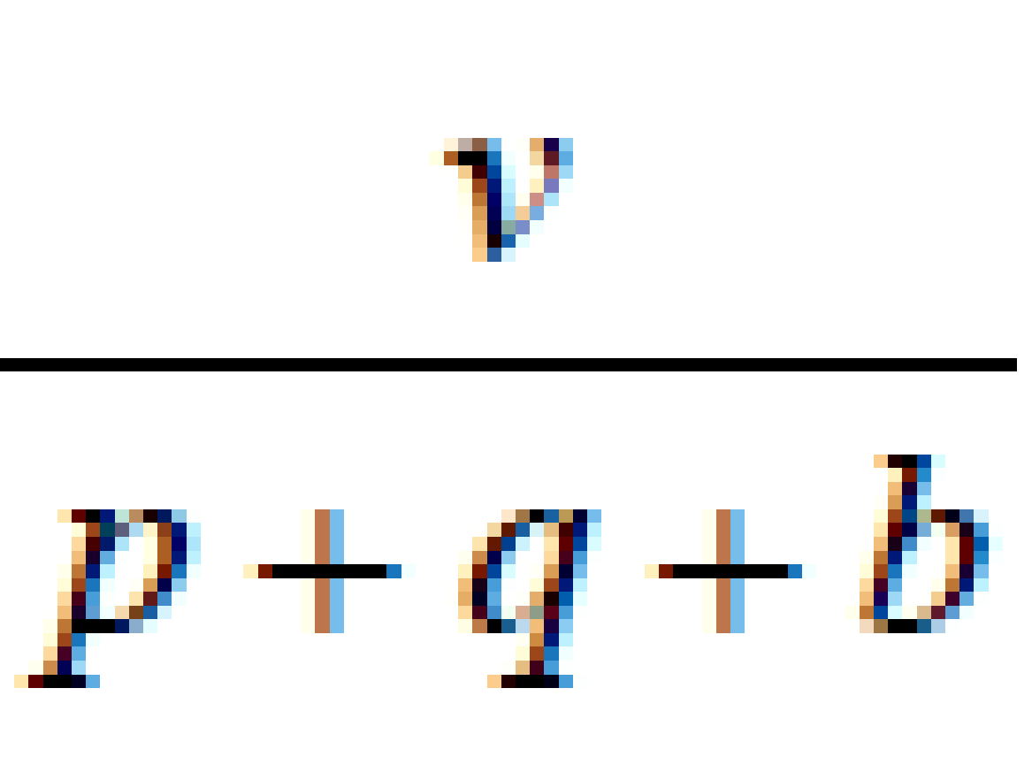
- Draw a speed-time graph for the motion of the train.
- If the average speed of the train for the whole journey is , find the value of b.

1990 (b)
A car accelerates uniformly from rest to a speed v m/s. It continues at this constant speed for t seconds and then decelerates uniformly to rest. The average speed for the journey is 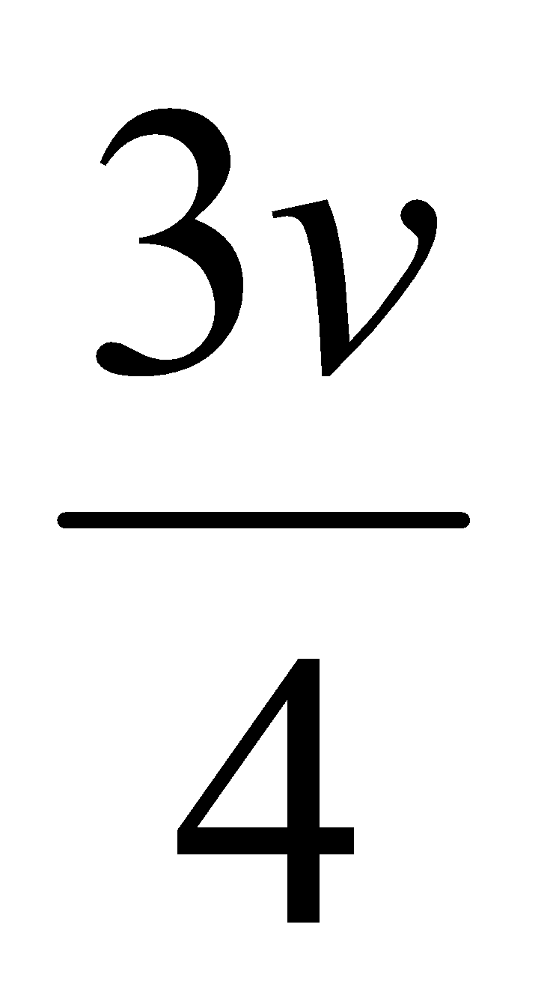.
- Draw a speed-time graph and hence, or otherwise, prove that the time for the journey is 2t seconds.
- If the car-driver had observed the speed limit of ½v, find the least time the journey would have taken, assuming the same acceleration and deceleration as in (i).

1979 (b)
A body starting from rest travels in a straight line, first with uniform acceleration a and then with uniform deceleration b.
It comes to rest when it has covered a total distance d.
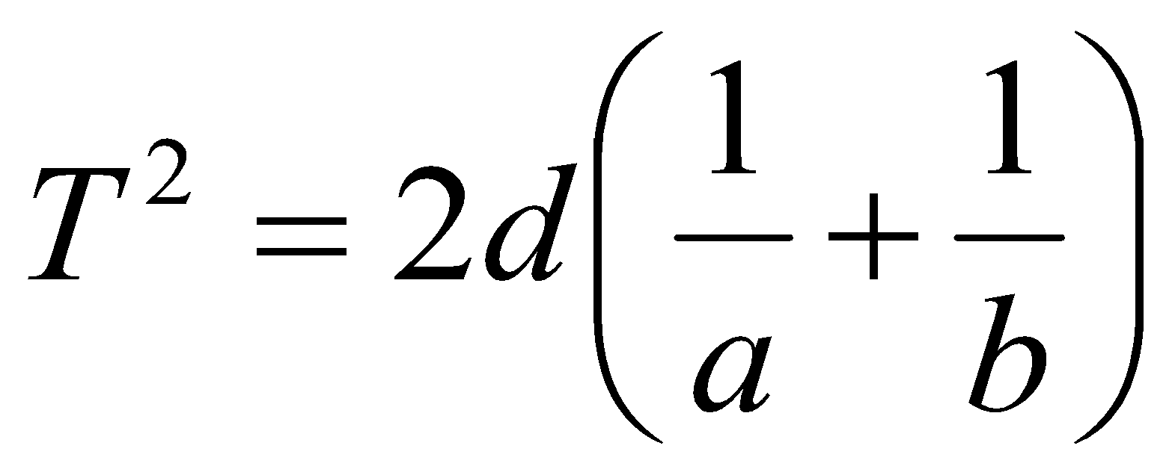
If the overall time for the journey is T, show that

1981
A body starts from rest at p, travels in a straight line and then comes to rest at q which is 0.696 km from p. The time taken is 66 seconds.
For the first 10 seconds if has uniform acceleration a₁.
It then travels at constant speed and is finally brought to rest by a uniform deceleration a₂ acting for 6 seconds.
- Calculate a₁ and a₂.
- If the journey from rest at p to rest at q had been travelled with no interval of constant speed, but subject to a₁ for time t₁ followed by a₂ for time t₂, show that the time for the journey is 8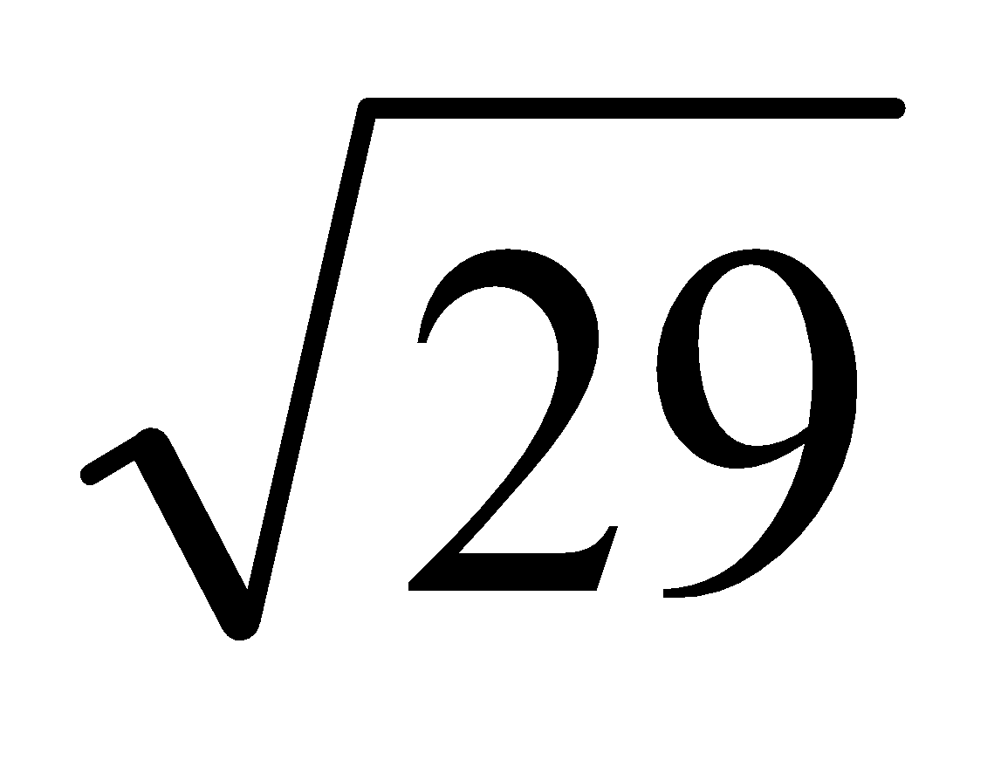 seconds.

1978
A driver starts from rest at P and travels with a uniform acceleration of a m/s² for T seconds.
He continues with uniform velocity for 3T seconds and then decelerates uniformly to rest at Q in a further 2T seconds.
Express the distance PQ in terms of a and T.
Another driver can accelerate at 2a m/s² and can decelerate at 4a m/s².
Find, in terms of T, the least time in which this driver can cover the distance PQ from rest to rest
- subject to a speed limit of 3aT m/s
- subject to a speed limit of 5aT m/s.

1972
A racing car covers a journey of 8.8 km from rest to rest.
It accelerates uniformly the first minute to reach its maximum speed of 40 m/s, it holds this speed for a certain time and then slows uniformly to rest with a retardation of magnitude three times that of the acceleration.
- Draw a rough velocity-time graph and find the distances travelled in the three stages of the journey and the total time taken.
- If the maximum speed over the final kilometre of the journey had been restricted to 20 m/s, show that the time taken from rest to rest would have been at least 22·5 seconds longer than before, assuming the same rates of acceleration and deceleration as before.

Questions requiring F_{net} = ma

2018 (a)
A parcel rests on the horizontal floor of a van.
The van is travelling on a level road at 14 m s^{–1}.
It is brought to rest by a uniform application of the brakes.
The coefficient of friction between the parcel and the floor is $\frac{2}{5}$.
Show that the parcel is on the point of sliding forward on the floor of the van if the stopping distance is 25m.

2005 (b)
A mass of 8 kg falls freely from rest.
After 5 s the mass penetrates sand.
The sand offers a constant resistance and brings the mass to rest in 0.01 s.
- Find the constant resistance of the sand
- Find the distance the mass penetrates into the sand.

1982 (b) {Note: all quantities must be in S.I. units}
A particle of mass 3 grammes falls from rest from a height of 0.4 m on to a soft material into which it sinks 0.0245 m.
Neglecting air resistance, calculate the constant resistance of the material.

This next two are both tricky and could be left as a revision exercise for sixth year

1970
A bullet of mass m is fired with speed v into a fixed block of wood and is brought to rest in a distance d. Find the resistance to motion assuming it to be constant.
Another bullet also of mass m is then fired with speed 2v into another fixed block of thickness 2d, which offers the same resistance as the first block.
Find the speed with which the bullet emerges, and the time it takes to pass through the block.

1994 (b)
In a lift, moving upwards with acceleration f, a spring balance indicates an object to have a weight of 98 N. When the lift is moving downwards with acceleration 2f the weight appears to be 68.8 N. Calculate
- the actual weight .
- the downward acceleration of the lift.

Fnet = ma (on a slope)
Where the objects are moving up a slope you should use the line of slope as the x-axis, which means that you will have to calculate the component of gravity along that direction. We study this when covering the Pulleys & Wedges topic.

Diagram

2019 (a)
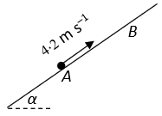
A particle P, of mass 3 kg, is projected along a rough inclined plane from the point A with speed 4∙2 m s^{–1}. The particle comes to instantaneous rest at B.
The plane is inclined at an angle 𝛼 to the horizontal where $tantan α= \frac{9}{40}$.
The coefficient of friction between the particle and the plane is $\frac{3}{20}$ .
- Show that the deceleration of P is $\frac{15g}{41}$.
- Find ∣AB∣.
- After reaching B the particle slides back down the plane.
Find the speed of P as it passes through A on its way back down the plane.

2004 (b)
A car of mass 1200 kg tows a caravan of mass 900 kg first along a horizontal road with acceleration f and then up an incline α to the horizontal road at uniform speed.
The force exerted by the engine is 2700 N.
Friction and air resistance amount to 150 N on the car and 240 N on the caravan.
- Calculate the acceleration, f, of the car along the horizontal road.
- Calculate the value of α, to the nearest degree.

2014 (b)
At a particular instant a car of mass 1200 kg is towing a trailer of mass 450 kg on a level road at a speed of 25 m s^{–1} when the engine exerts a constant power of 50 kW.
Friction and air resistance amount to 930 N on the car and 200 N on the trailer.
- Find the acceleration of the car at this instant.
- Calculate the maximum speed at which the car (without the trailer) could travel up an incline of $\frac{1}{10}$ against the same resistance with the engine working at the same rate.

1999 (a)
A car of mass 1500 kg travels up a slope of gradient sin⁻¹ $\left(\frac{1}{50}\right)$ against a constant resistance of 0.2 N per kilogram.
Find
- the constant force required to produce a slope an acceleration of 0.1 m/s².
- the power which is developed when the speed is 20 m/s.

2017 (b) {Answer this only after covering Conservation of Energy}
A baggage chute has two sections, PQ and QR, as shown in the diagram.
PQ is smooth and is a quarter circle of radius r.
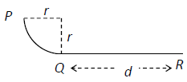
QR, of length d, is rough and horizontal.
The coefficient of friction between the bag and section QR is μ.
A bag of mass m kg is released from rest at P and comes to rest at R.
Find
- the speed of the bag at Q in terms of r
- d in terms of μ and r.
- The speed of the bag when it is halfway along QR is 7 m s^{–1}.
Find the value of r.

2020 (b) {Answer part (ii) only after covering Conservation of Momentum}
A 60 gram mass is projected vertically upwards with an initial speed of 15 m s^{–1} and half a second later a 40 gram mass is projected vertically upwards from the same point with an initial speed of 22.65 m s^{–1}.

- Calculate the height at which the masses will collide.
- The masses coalesce on colliding.
Find the greatest height which the combined mass will reach.

Answering Higher Level Exam Questions 1995 - 2009
There are usually many ways to answer these questions; I usually go with the method outlined in the marking schemes.
2009 (a)
Use v = u + at for both particles. Then use v² = u² + 2as for both particles to get the required expression.

2009 (b)
- Velocity-time graph
- You need to play around with lots of algebra. Get an expression for total time in terms of v and f, then use the fact that average speed = total distance/total time to get an answer of f = 1 m s⁻².

2008 (a)
- Straightforward. Ans: t = 4 s.
- Need to distinguish between the concepts of distance and displacement.
On the way up, distance and displacement will be the same, but in this question after 5 seconds the ball will have been on its way down for 1 sec (how do we know this?), so we need to establish how far it will have travelled in the fifth second and add this on to the maximum height.
Ans: total distance = 83.3 m

2008 (b)
- You know v, u and t for Q (t is when Q passes P), so use this to work out a.
Now use this to work out s (distance from the beginning to where Q passes P).
Now for P you have this same s, plus u and t, so use this to work out a for P.
Ans: a_{Q} = 0.5 m s⁻², a_{P} = 5/24 m s⁻².
- Use v = u + at to find v for P. Ans: v_{P} = 48 m s⁻².
- “When” they are moving at equal speeds ⇒ v_{P} = v_{Q} so get an expression for both and equate.
Use this to find t. Sub into expressions for S_{P} and S_{Q} and subtract one from the other to find the distance between them.
Ans: distance = 525 m

2007 (a)
- It’s not obvious, but this is a ‘Train-track’ type question.
During the third second of its motion the particle travels 29.9 metres.
We can get an expression for h - the distance travelled in the first 2 seconds: we know u, a and t.
We can then do the same for the distance travelled in the first 3 seconds. S in this case is (h + 29.9) m.
Ans: u = 5.4 m s⁻¹
- Straightforward. Ans: s = 100 m.

2007 (b)
- Straightforward.
- Tricky: One car – two accelerations
You need to remember that $Average Speed=\frac{Total distance}{Total time}$, so we need to find an expression for this in relation to the information supplied, and then compare that to the expression they give us.
For each section write down the relationship between velocity, distance and time

To find the total time you need to find an expression for each of the 3 individual times (in terms of velocity and distance).
Then it’s just messy algebra to finish it out.
Ans: b = 1

2006 (a)
Acceleration / deceleration type question.
- Straightforward
- Messy algebra. Ans: d = 3/8 ft²
2006 (b)
- Straightforward.
- Straightforward once you draw a diagram to help you verify that S_{P} + S_{Q} = 159. Then solve. Ans: t = 6 s.
- Straightforward. Ans: t = 3.1 s.

2005 (a)
- Straightforward (once you note that the acceleration is minus). Ans: s = 33.3 m
- Note that there are two distances to take into account here. The first is to do with reaction-time distance, and the second is the normal stopping distance. Add these together but remember that you have to subtract the first distance of 33.3 m because the first car will have moved on by this distance. Ans: s = 43.3 m.

2005 (b)
- Straightforward once you are familiar with the concept of F_{net} = ma.
To find out the forces acting on the mass in the sand you will need to work out its acceleration. Before you can do this you will first need to note that its initial velocity for the second stage (when it’s in the sand) will be the same as its final velocity in the air. So that gives you u; you know v = 0 and t = 0.01. From that you can work out acceleration a.
Then it’s just Force_{down} – Force_{up} = ma, where Force_{down} = mg, and Force_{up} is due to resistance of the sand, which is what you are looking for.
Ans: R = 39278.4 N.

- Straightforward. Ans: s = 0.245 m.

2004 (a)
- Straightforward. s₁ = s₂. Note that first ball is in the air for 3 seconds and second ball is in the air for 2 seconds.
Ans: u = 17.75 ms⁻¹.
- You first have to establish for each ball whether it will be on the way up or the way down. Hint: look at their initial velocities and the time they taken to reach max. height. Draw a diagram for each ball to help you.
Ans: Ball A = 25 m, ball B = 16 m.

2004 (b)
- Straightforward once you are familiar with F_{net} = ma.
Ans: f = 1.1 m s⁻²
- Similar to (i), except in this case the car and caravan are going uphill so you will have to and also resolve the weight into components along the plane and perpendicular to the plane, and proceed accordingly.
Ans: α = 6⁰.

2003 (a)
- Straightforward train-track question.
- Straightforward once you remember that all numbers must be in relation to point p, so total distance travelled before coming to rest is (250 + s). Remember also that a = -3.
Ans: s = 51 m.

2003 (b)
- Man just catches bus, so at this time v_{Man} = v_{bus}. Also when the man catches up with the bus he will hae travelled 40 m more than the bus, so s_{Man} = (40 + s_{Bus}).You will need to play around with the various equations of motion and use lots of algebra to solve.
Ans: u = 4 m s⁻¹.
- Find the distance between them means find get an expression for the distance travelled by both and subtract one from the other. In this case you are asked to find the minimum distance, so anytime maximum or minimum is asked for it usually means you have to differentiate and let your answer equal 0 to find t (remember from maths how to find the maximum or minimum point on a curve? – this is one of the most important applications of differentiation).
Ans: s = 17.5 m.

2002 (a)
- Straightforward. Note s = -30. Ans: u = 18.5 ms⁻¹.
- Straightforward. Ans: speed = 30.5 m s⁻¹ (remember strictly speaking ‘speed’ implies magnitude only, not direction, so we should ignore the minus sign).

2002 (b)
- Train-track type question. Straightforward.
- Straightforward.

2001 (a)
- Velocity-time graph. Lots of algebra. See notes for answering this type of question above.
Ans: t = 75 seconds.
- Acceleration-deceleration. Algebra. See notes above.
Ans: t = 60 seconds.

2001 (b)
- Two balls are thrown up and collide in the air so remember that the key is s₁ = s₂. Remember also that if the second ball is in the air for t₁ seconds, then the first ball (which is obviously in the air for longer) is in the air for (T + t₁) seconds. Note also that you were asked for the time taken in relation to when the first particle was projected, so you may have to adjust your answer accordingly.
- Sub value for time into expression for s.

2000 (a)
This involves a stone projected upwards, but is actually a type of train-track type question because all information must be with reference to the initial point of projection.
Ans: u = 56 m s⁻¹.

2000 (b)
- Velocity-time diagram
The cars are moving in opposite directions so when they meet the total distance travelled will be 10,000 m, i.e. s_{p} + s_{q} = 10,000 m.
Ans: t = 215 s, s_{p} = 4875 m, s_{q} = 5125 m.
- Cars meet halfway ⇒ s_{p} = s_{q}.
Ans: t = 10 s.

1999 (a)
- Straightforward F_{net} = ma question using the line of slope as the x-axis.
Ans: F = 744 N
- Power = Force × velocity
Ans: P = 14880 W

1999 (b)
- Velocity-time graph
- You need to play around with lots of algebra.
Ans: u = 4/t
- Again, play around with the equations
Ans: Total distance = 75.76 m.

1998 (a)
- Velocity-time graph. Very difficult algebra. Remember $Average Speed=\frac{Total distance}{Total time}$

1998 (b)
- Straightforward in principle, although the algebra gets a little messy.
Ans: u = 0.1 m s⁻¹, b = 1
- Straightforward.
Ans: s = 94.5 m

1997 (a)
Straightforward if you begin by throwing down all the relationships between acceleration, velocity, time and distance as per revision notes. Then just play around with the equations.
- Answer: v = 7.5 m/s
- Answer: distance = 21 m

1997 (b)
- Nice question, but could cause difficulty in that the questions wouldn’t be familiar. When particles collide then S1 + S2 = d.
- Tricky to decipher the significance of the information. You’ve just worked out an expression for the time for collision – call this t1. Now work out an expression for the time for the second particle to come to instantaneous rest – call this t2.
Now let t1 < t2 to obtain the required expression.
- If the second particle has returned to q then S2 = 0, so get the time for this and let it equal to t1 (time at which collision would have taken place) and obtain the required expression.

1996 (a)
- Straightforward train-track type problem
Answer: a = 3.5 m s⁻²
- Straightforward
Answer: s = 7 m

1996 (b)
- Straightforward
- Straightforward if you begin by throwing down all the relationships between acceleration, velocity, time and distance as per revision notes. Then just play around with the equations.

1995 (a)
A variation on the train-track problem. Use v² = u² + 2as for stage pq and stage qr.
Answer: v = 5u.
Straightforward. t1 = 4u/f and t2 = 2u/f.

1995 (b)
- Straightforward. Answer: u = √6 g
- Straightforward. Answer: t = 0.26 seconds
- Straightforward. Answer: S6 = S2 = 5/3, S5 = S3 = 8/3, S4 = 3

Answers to Ordinary Level Exam Questions 2000 - 2017
2017
(a)
- a = 3 m s⁻²
- a = - 4 m s⁻²
- ⏐PQ⏐ = 480 m
- Average speed = 20 m s⁻¹

(i)
(ii) k = 40

2016
(b)
- a = 2 m s⁻²
- a = - 4 m s⁻²
- ⏐PQ⏐ = 448 m
- Average speed = 22.4 m s⁻¹
- t = 5.7 s

2015
(a)
- a = - 4 m s⁻²
- a = 3 m s⁻²
- ⏐PQ⏐ = 426 m
- Average speed = 21.3 m s⁻¹
(b)
100 km hr⁻¹ = 27.7m s⁻¹
26 < 27.7 so no.

2014
- a = 3 m s⁻²
- a = - 4 m s⁻²
- ⏐PQ⏐ = 317.5 m
- Average speed = 15.12 m s⁻¹

2013
- a = - 2 m s⁻²
- a = 4 m s⁻²
- ⏐PQ⏐ = 592 m
- v = 20 m s⁻¹
- Average speed = 18.75 m s⁻¹

2012
- a = 2 m s⁻²
- a = - 4 m s⁻²
- ⏐PQ⏐ = 592 m
- v = 24 m s⁻¹

2011
- a = 2 m s⁻²
- a = - 1 m s⁻²
- ⏐PQ⏐ = 230 m
- Average speed = 17.7 m s⁻¹

2010
- a = 3 m s⁻²
- a = -10 m s⁻²
- ⏐PQ⏐ = 621 m
- Average speed = 25.875 m s⁻¹

2009
- V_{A} = 17 m s⁻¹, V_{B} = 33 m s⁻¹
- S_{A} = 70 m, S_{B} = 133 m
- t = 14.8 s

2008
- Retardation = 2.5 m s⁻²
- t = 4 s
- s = 80 m
- v = 14.1 m s⁻¹

2007

- a = 3 m s⁻²
- a = - 5 m s⁻²
- s = 360 m
- v = 9 m s⁻¹

2006
- Acceleration = 4 m s⁻²
- Deceleration = 5 m s⁻²
- Distance = 460 m
- Average speed = 23 m s⁻¹

2005

- a = 2 m s⁻²
- Deceleration = 1 m s⁻²
- s = 600 m
- average speed = 40/3 m s⁻¹

2004
- Retardation = - 0.875 m s⁻²
- t = 40/7 s
- v = 5√2 m s⁻¹
- s = 29 m

2003

- a = 1 m s⁻²
- a = -4 m s⁻²
- s = 80 m
- v = 40/3 m s⁻¹

2002
- a = 2 m s⁻²
- t = 40 s
- t = 75s
2001
- V_{A} = 22 m s⁻¹
V_{B} = 31 m s⁻¹
- S_{A} = 120 m
S_{B} = 160 m
- u = 14 m s⁻¹

2000

- Acceleration = 2.5 m s⁻²
- Deceleration = 5 m s⁻²
- Distance = 715 m
- time = 36.1 s

Linear acceleration questions from 2023 and Sample Paper: Ordinary level and Higher level

Sample paper Ordinary Level Question 8
Pole 𝑃 and traffic lights 𝐿 lie 800 m apart on a straight level road, as in the diagram below.
A car passes 𝑃 travelling towards 𝐿 with a speed of 5 m s^{–1} and an acceleration of 0.4 m s^{–2}.
At the same moment, a motorcycle passes 𝐿 travelling towards 𝑃 with a speed of 4 m s^{–1} and an acceleration of 0.6 m s^{–2}.

- Calculate the speed of the car 15 s after it passes 𝑃.
- Draw a velocity‐time graph for the motion of the car for the first 15 s after it passes 𝑃.

- Write an expression for 𝑠_{c}(𝑡), the displacement of the car from 𝑃 at any time 𝑡.
- Write an expression for 𝑠_{m}(𝑡), the displacement of the motorcycle from 𝐿 at any time 𝑡.
- The car and the motorcycle pass each other after 𝑇 seconds. Calculate 𝑇.

- At the instant that the car and motorcycle pass each other, the car stops accelerating and continues travelling at the velocity it has at that instant.
Calculate the total time it takes the car to travel from 𝑃 to 𝐿.

2023 OL Question 6
A car is parked at a point 𝑃. At time 𝑡 = 0 s the car begins to travel in a straight line with a constant acceleration of 4.5 m s^{–2}. When the car has reached a velocity of 18 m s^{–1} it stops accelerating. The car continues travelling at a velocity of 18 m s^{–1} until 𝑡 = 30 s.
- Calculate the time it takes for the car to reach 18 m s^{–1}.
- Calculate the distance travelled by the car while it is accelerating.
- Calculate the distance travelled by the car when 𝑡 = 30 s.

At 𝑡 = 0 a cyclist passed the car while travelling with a velocity of 8.5 m s^{–1} and an acceleration of 0.5 m s^{–2}. The cyclist accelerated until he reached a velocity of 11 m s^{–1}, which he then maintained.
- Calculate the time taken for the cyclist to reach a velocity of 11 m s^{–1}.
- Using the axes below, draw an accurate velocity‐time graph showing the motion of the car and the motion of the cyclist for the first 30 s of their motion.
- Calculate the distance between the car and the cyclist when 𝑡 = 20 s.

Sample Paper HL Question 3 (b)
Two athletes, Brian and Clara, are taking part in a relay race. Brian is preparing to hand over the baton to Clara. During the hand‐over of the baton the athletes need to be running in the same straight line and at the same velocity.
As Brian approaches Clara’s position at a constant speed of 11 m s^{–1}, Clara starts running from rest with constant acceleration 𝑓.
A short time later Brian begins to decelerate at 2 m s^{–2}.
Clara receives the baton 2.5 s after she starts running.
The baton is exchanged when Clara is 75 cm ahead of Brian and when both athletes have a speed of 8 m s^{–1}.
After the baton is exchanged, Brian continues to decelerate at 2 m s^{–2} until he comes to rest.
Clara continues to accelerate at 𝑓 until she reaches her maximum speed of 12 m s^{–1}, which she then maintains.
- Calculate the time it takes for Brian to decelerate before he exchanges the baton.

- Using the axes below, draw an accurate velocity‐time graph for the motion of each runner.
Time is measured from the instant that Clara begins to run.
Relevant calculations should be shown in the space below.

- Calculate the distance between the two athletes when Clara begins to run.

2023 HL Question 5 (b)
Áine travels by car from her house to work each morning.
On Monday morning she starts her car and accelerates uniformly for 40 s to a speed of 22.5 m s^{–1}.
Áine then travels at this speed for 8 minutes until decelerating uniformly to rest at her work.
She reaches her work at exactly 08: 30.
On Tuesday morning Áine leaves her house 140 s later than the day before.
She takes the same route to work.
She starts her car and accelerates at 1.5 m s^{–2} for 20 s, then maintains this steady speed for 6 minutes before decelerating uniformly to rest at her work.
She again reaches her work at exactly 08: 30.
Calculate the time when Áine leaves her house on Tuesday morning.

